**System Requirements**

System Requirements are what the system must do or what characteristics it needs to have. It’s important to understand who will use the system, what the system will do, and where and when it will be used. System Requirements are broken down into Functional Requirements and Nonfunctional Requirements.

**Functional Requirements**

Functional requirements relate directly to a process the system must be able to perform or information it must possess. They describe how the system behaves and the functions of the system. The functional requirements for this project include:

**Process-oriented**

* 1. Will allow administrators to add, edit, and delete entities for stakeholders (researchers, students, industry, community, and event attendees)
  2. Will allow administrators to add, edit, and delete entities for events
  3. Will allow administrators to add, edit, and delete entities for grants
  4. Will allow users to send messages directly to the UofL Office of Research and Innovation through contact us form.
  5. Will allow administrators to add, edit, and delete entities for surveys and create reports on surveys
  6. Will allow attendees to keep track of and RSVP for events
  7. Will allow administrators to upload and download files.
  8. Will allow administrators to add, edit, and delete pages.
  9. Will allow users to log in to user-created profiles
  10. Will direct potential donations to Development
  11. Will use logins as preconditions for user-related functions

**Information-oriented**

* 1. Will save search results for users
  2. Will include current and upcoming events for users to view
  3. Will include statistics and facts related to R&I
  4. Will include updates on current and future projects

**Nonfunctional Requirements**

Nonfunctional Requirements refer to behavioral properties. This includes the performance and usability of the system. If it doesn’t produce information for the user, it is nonfunctional. These requirements are usually related to scalability, reliability, data integrity, and more.

**Operational**

* 1. Will be capable of running on Windows, Mac, and other relevant environments
  2. Will be integrated into the current system.
  3. Will be optimized to operate on properly on desktops, mobile devices, and tablets.
  4. Will be capable of running on any Web browser
  5. Will run on an efficient Content Management System, such as WordPress

**Performance**

* 1. System will be more user-friendly.
  2. System will be easy navigate.
  3. The system will be operational 24/7.
  4. System will execute in two seconds or less.
  5. System will update social media feeds every minute.
  6. System will be organized well and be informative.
  7. System will run functional calendar and events

**Security**

* 1. System will include industry-standard security measures/safeguards
  2. System will have a proper backup and recovery protocol
  3. System will update when necessary
  4. System will have varying levels of privilege so that the relevant information is available to a specific user and nothing

**Use Case Diagrams**

The following use case diagram shows the various interactions between the Admin and the site as well as potential Users and the site. Each line points to a use case that an actor would perform. The figures on the left are the primary actors in each use case.



  

**Trace Matrix**

|  |  |  |  |  |  |  |  |  |  |  |  |  |  |  |  |  |
| --- | --- | --- | --- | --- | --- | --- | --- | --- | --- | --- | --- | --- | --- | --- | --- | --- |
|  | Requirement 1 | Requirement 2 | Requirement 3 | Requirement 4 | Requirement 5 | Requirement 6 | Requirement 8 | Requirement 9 | Requirement 11 | Requirement 12 | Requirement 13 | Requirement 14 | Requirement 15 | Requirement 16 | Requirement 17 | Requirement 25 |
| Use Case 1 |  | **X** |  |  |  |  |  |  |  |  |  |  |  |  |  |  |
| Use Case2 |  | **X** |  |  |  |  |  |  |  |  |  |  |  |  |  |  |
| Use Case3 |  | **X** |  |  |  |  |  |  |  |  |  |  |  |  |  |  |
| Use Case4 |  |  |  |  | **X** |  |  |  |  |  |  |  |  |  |  |  |
| Use Case5 |  |  |  |  | **X** |  |  |  |  |  |  |  |  |  |  |  |
| Use Case6 |  |  |  |  | **X** |  |  |  |  |  |  |  |  |  |  |  |
| Use Case7 |  |  |  |  |  | **X** |  |  |  |  |  |  |  |  |  |  |
| Use Case8 |  |  |  |  |  | **X** |  |  |  |  |  |  |  |  |  |  |
| Use Case9 |  |  |  |  |  | **X** |  |  |  |  |  |  |  |  |  |  |
| Use Case10 |  |  |  |  |  |  |  |  |  |  |  |  | **X** |  |  |  |
| Use Case11 |  |  | **X** |  |  |  |  |  |  |  |  |  |  |  |  |  |
| Use Case12 |  |  |  |  |  |  |  |  |  |  | **X** |  |  |  |  |  |
| Use Case13 |  |  |  |  |  |  |  |  |  |  |  |  | **X** |  |  |  |
| Use Case14 |  |  | **X** |  |  |  |  |  |  |  |  |  |  |  |  |  |
| Use Case15 |  |  |  |  |  |  |  |  |  |  |  |  | **X** |  |  |  |
| Use Case16 |  |  | **X** |  |  |  |  |  |  |  |  |  |  |  |  |  |
| Use Case17 |  |  |  |  |  |  |  |  |  |  | **X** |  |  |  |  |  |
| Use Case18 |  |  |  |  |  |  |  |  |  |  | **X** |  |  |  |  |  |
| Use Case19 |  |  |  |  |  |  |  |  |  |  |  | **X** |  |  |  |  |
| Use Case20 |  |  |  |  | **X** |  |  |  |  |  |  |  |  |  |  |  |
| Use Case21 |  |  |  |  | **X** |  |  |  |  |  |  |  |  |  |  |  |
| Use Case22 |  |  |  |  | **X** |  |  |  |  |  |  |  |  |  |  |  |
| Use Case23 |  |  |  |  |  |  |  | **X** |  |  |  |  |  |  |  |  |
| Use Case24 |  |  |  |  |  |  |  | **X** |  |  |  |  |  |  |  |  |
| Use Case25 |  |  |  |  |  |  |  | **X** |  |  |  |  |  |  |  |  |
| Use Case26 |  |  |  |  |  |  |  | **X** |  |  |  |  |  |  |  |  |
| Use Case27 |  |  |  |  |  |  |  | **X** |  |  |  |  |  |  |  |  |
| Use Case28 |  |  |  | **X** |  |  |  |  |  |  |  |  |  |  |  |  |
| Use Case29 |  |  |  |  |  |  | **X** |  |  |  |  |  |  |  |  |  |
| Use Case30 |  |  |  |  |  |  |  |  |  | **X** |  |  |  |  |  |  |
| Use Case31 |  |  |  |  |  |  |  |  |  | **X** |  |  |  |  |  |  |
| Use Case32 |  |  |  |  |  |  |  |  |  | **X** |  |  |  |  |  |  |
| Use Case33 |  |  |  |  |  |  |  |  |  | **X** |  |  |  |  |  |  |
| Use Case34 |  |  |  |  |  |  |  |  |  |  |  |  |  |  |  | **X** |
| Use Case35 |  |  |  |  |  |  |  |  |  |  |  |  |  |  |  | **X** |
| Use Case36 |  |  |  |  |  |  |  | **X** |  |  |  |  |  |  |  |  |
| Use Case37 |  |  |  |  |  |  | **X** |  |  |  |  |  |  |  |  |  |
| Use Case38 |  |  |  |  |  |  |  |  |  |  |  |  |  |  | **X** |  |
| Use Case39 |  |  |  |  |  |  |  |  |  | **X** |  |  |  |  |  |  |
| Use Case40 |  |  |  |  |  |  |  |  |  | **X** |  |  |  |  |  |  |
| Use Case41 |  |  |  |  |  |  |  |  |  | **X** |  |  |  |  |  |  |
| Use Case42 | **X** |  |  |  |  |  |  |  |  |  |  |  |  |  |  |  |
| Use Case43 | **X** |  |  |  |  |  |  |  |  |  |  |  |  |  |  |  |
| Use Case44 | **X** |  |  |  |  |  |  |  |  |  |  |  |  |  |  |  |
| Use Case45 | **X** |  |  |  |  |  |  |  |  |  |  |  |  |  |  |  |
| Use Case46 |  |  |  |  |  |  |  |  |  |  |  | **X** |  |  |  |  |
| Use Case47 |  |  |  |  |  |  |  |  |  |  |  | **X** |  |  |  |  |
| Use Case48 |  |  |  |  |  |  |  |  |  |  |  | **X** |  |  |  |  |
| Use Case49 |  |  |  |  |  |  |  |  |  |  | **X** |  |  |  |  |  |
| Use Case50 |  |  |  |  |  |  |  |  |  |  |  |  | **X** |  |  |  |
| Use Case51 |  |  |  |  |  |  |  |  |  |  |  |  | **X** |  |  |  |

Use Case Specification: Create Event

# Create Event

## Brief Description

This use case describes how an administrator would create an event for the R&I website through a form.

# Flow of Events

## Basic Flow

* Admin selects “Create Event” button
* Admin inputs event Title
* Admin inputs event Date
* Admin inputs event Start Time
* Admin inputs event End Time
* Admin inputs event Location
* Admin inputs event About Event information
* Admin inputs any desired pictures
* Admin selects “Submit”
* Use case ends

# Special Requirements

## CMS allows for the addition of widgets

# Pre-conditions

## Events widget works properly

## System must be up and running

# Post-conditions

## Event is created

## Events widget and section are populated with the new event

Use Case Specification: Edit Event

# Edit Event

## Brief Description

This use case describes how an administrator would edit an event on the R&I website

# Flow of Events

## Basic Flow

* Admin selects “Edit Events”
* Admin selects event to edit
* Admin inputs new information
* Admin selects “Submit”
* Use case ends

# Special Requirements

## Database that holds event information

## System runs on desktops, mobile devices, and tablets

## System runs on windows and mac operating systems

# Pre-conditions

## There are existing events on the site

## System must be up and running

# Post-conditions

## System updates the event information

## System updates the event on a user calendar

Use Case Specification: Delete Event

# Delete Event

## Brief Description

This use case describes how an administrator would delete an event off the R&I website

# Flow of Events

## Basic Flow

* Admin selects “Delete Events”
* Admin selects event to delete
* Admin selects “Submit”
* Use case ends

# Special Requirements

## Database that holds event information

## System runs on desktops, mobile devices, and tablets

## System runs on windows and mac operating systems

# Pre-conditions

## There are existing events on the site

## System must be up and running

# Post-conditions

## System removes the event from events widget and list

Diagram 1 shows the sequence diagram for creating, editing, and deleting an event. The primary actor in this diagram is the admin. The first column shows the steps the actor will take when creating an event. This includes processes such as loading up the event form and inputting any relevant information. This information is sent to the database and then recorded. Confirmation will then be sent back to the user to show it worked.



* Admin selects “Event”
* Admin inputs event Title
* Admin inputs event Date
* Admin inputs event Start Time
* Admin inputs event End Time
* Admin inputs event Location
* Admin inputs event About Event information
* Admin inputs picture
* Admin selects “Submit”
* Use case ends

Diagram 1

Use Case Specification: Create Survey

# Create Survey

## Brief Description

This use case describes how an administrator would create a survey for the R&I website.

# Flow of Events

## Basic Flow

* Admin selects “Create Survey”
* Admin inputs survey Title
* Admin inputs necessary survey Questions
* Admin selects “Submit”

# Special Requirements

## System runs on desktops, mobile devices, and tablets

## System runs on windows and mac operating systems

# Pre-conditions

## Website supports surveys

## User is already logged in to the user profile

## System must be up and running

# Post-conditions

## System gives users the option to take survey

## System accepts the survey from users

## System can create reports off the survey

Use Case Specification: Edit Survey

# Edit Survey

## Brief Description

This use case describes how an administrator would edit a survey on the R&I website

# Flow of Events

## Basic Flow

* Admin selects “Edit Survey”
* Admin selects survey to edit
* Admin inputs new questions or information
* Use case ends

# Special Requirements

## Database that holds survey information

## System runs on desktops, mobile devices, and tablets

## System runs on windows and mac operating systems

# Pre-conditions

## There are existing surveys on the site

## System must be up and running

# Post-conditions

## System updates the surveys with new information

Use Case Specification: Delete Survey

# Delete Survey

## Brief Description

This use case describes how an administrator would delete a survey from the R&I website

# Flow of Events

## Basic Flow

* Admin selects “Delete Survey”
* Admin selects survey to be deleted
* Admin selects “Submit”

# Special Requirements

## Database that holds survey information

## System runs on desktops, mobile devices, and tablets

## System runs on windows and mac operating systems

# Pre-conditions

## There are existing surveys on the site

## System must be up and running

# Post-conditions

## System removes that survey from the site

Diagram 2 shows the sequence diagram for creating, editing, and deleting a survey. The primary actor in this diagram is the admin. The first column shows the steps the actor will take when creating a survey. This includes processes such as loading up the survey form and inputting any relevant information. This information is sent to the database and then recorded. Confirmation will then be sent back to the user to show it worked.



* Admin selects “Survey” form
* Admin inputs survey Title
* Admin selects “Add Question”
* Admin inputs Question Type
* Admin inputs Question
* Admin selects “Submit”

Diagram 2

Use Case Specification: RSVP for Event

# RSVP for Event

## Brief Description

This use case describes how a user would RSVP for an event located in the events widget or the expanded, full list of events.

# Flow of Events

## Basic Flow

* User selects “RSVP” on event
* User selects “Confirm RSVP”
* Use case ends

## Alternative Flow

* User selects “See All Events” on events widget
* User selects “RSVP” on event
* User selects “Confirm RSVP”
* Use case ends

# Special Requirements

## Database that holds event information

## System runs on desktops, mobile devices, and tablets

## System runs on windows and mac operating systems

# Pre-conditions

## There are existing events on the site

## User is already logged in to the user profile

## System must be up and running

# Post-conditions

## System shows that user as an Attendee

## System shows that the user has an RSVP for the event

## System shows the event on a user calendar

Use Case Specification: Cancel for Event

# Cancel for Event

## Brief Description

This use case describes how a user would cancel for an event located in the events widget, the expanded list of events, or through their user profile.

# Flow of Events

## Basic Flow

* User selects “RSVP” on event
* User selects “Cancel RSVP”
* Use case ends

## Alternative Flow

* User selects “See All Events” on events widget
* User selects “RSVP” on event
* User selects “Cancel RSVP”
* Use case ends

# Special Requirements

## Database that holds event information

## System runs on desktops, mobile devices, and tablets

## System runs on windows and mac operating systems

# Pre-conditions

## There are existing events on the site

## User is already logged in to the user profile

## System must be up and running

## User has already RSVPed for event

# Post-conditions

## System removes that user as an Attendee

## System no longer shows that the user has an RSVP for the event

## System removes the event on a user calendar

Diagram 3 shows the sequence diagram for an RSVP and Cancelling an RSVP. The primary actor in this diagram are users such as researchers. The first column shows the steps the actor will take in relation to making or cancelling an RSVP. This includes processes such selecting RSVP on an event and inputting any relevant information. Preconditions like already being Logged in to a user profile make this event much quicker. This information is sent to the data base and then recorded. Confirmation will then be sent back to the user to show confirmation of an RSVP.



* User selects “RSVP” on event
* User selects “Confirm”
* Use case ends

Diagram 3

Use Case Specification: Look Up Core Facilities

# Look Up Core Facilities

## Brief Description

This use case describes how a user would look up core facilities on the R&I website.

# Flow of Events

## Basic Flow

* User selects “For Researchers” tab
* User selects “Core Facilities”
* User selects
* Use case ends

# Special Requirements

## System runs on desktops, mobile devices, and tablets

## System runs on windows and mac operating systems

# Pre-conditions

## There is an existing section populated with the core research facilities

## System must be up and running

# Post-conditions

## System allows users to look at each facility

## System displays pictures relevant to each facility

Diagram 4 shows the sequence diagram for looking up core facilities. The primary actor in this diagram are users such as researchers. The first column shows the steps the actor will take when creating an event. This includes processes such as accessing the For Researchers tab and selecting specific Facilities. This information is sent to the data base and then recorded. Confirmation will then be sent back to the user to show the desired facility.



* User selects “For Researchers” tab
* User selects “Core Facilities”
* User selects “Specific Facility”
* Use case ends

Diagram 4

Use Case Specification: <Create Announcement>

# Create Announcement

## Brief Description

User creates announcement page to be displayed in the announcements list

# Flow of Events

## Basic Flow

* User selects the create announcement option in the administrative tab
* Enter announcement title
* Enter announcement text body
* Enter announcement post date
* Enter announcement post time
* Enter announcement automatic deletion date
* Submit
* Redirect to blank create announcement template
* Use case ends

# Special Requirements

# Pre-conditions

## Database containing announcement data is online

## Website is online

## User has administrative privileges

# Post-conditions

# Extension Points

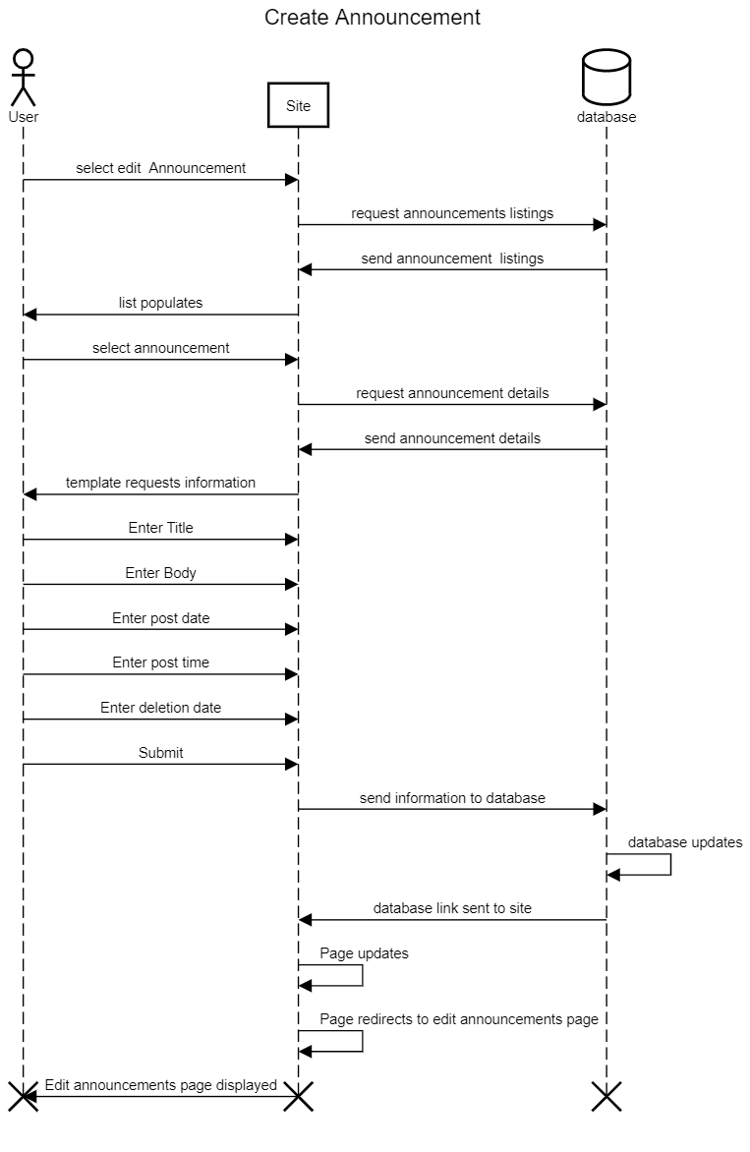

Use Case Specification: <Create Grant>

# Create Grant

## Brief Description

User creates grant information posting

# Flow of Events

## Basic Flow

* Select Create Grant from administrative tab
* Enter Grant title
* Enter grant issuer
* Enter grant Amount
* Enter grant description
* Enter grant application due date
* Submit
* Redirect to administrative tab
* Use case ends

## Alternative Flows

# Special Requirements

# Pre-conditions

## Website is online

## Grants database online

## User has administrative privileges

# Post-conditions

# Extension Points

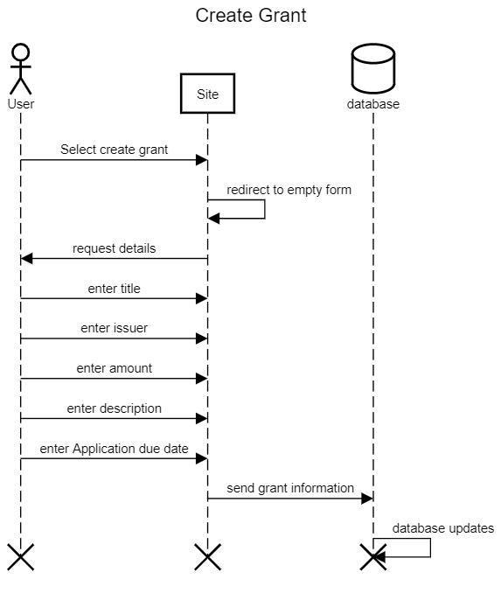

Use Case Specification: <Create Newsletter post>

# Create Newsletter post

## Brief Description

User will draft a newsletter post which will then be emailed to all addresses that have signed up.

# Flow of Events

## Basic Flow

* Select New Newsletter from the administrative tab
* Enter title
* Enter text body
* Select send date
* Submit
* Use case ends

## Alternative Flows

# Special Requirements

# Pre-conditions

## User has administrative privileges

## Website is online

## Newsletter email database is online

## Website is online

# Post-conditions

# Extension Points

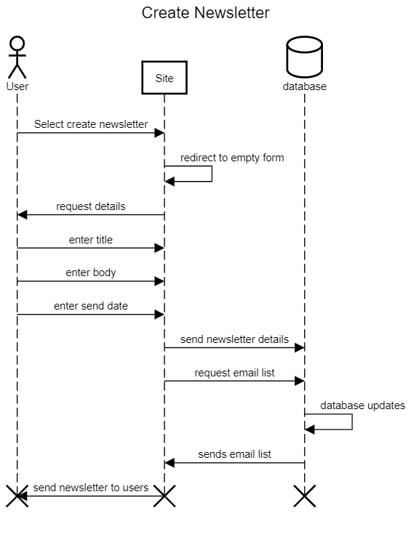

Use Case Specification: <Delete Announcement>

# Delete Announcement

## Brief Description

User deletes pre-existing announcement

# Flow of Events

## Basic Flow

* User selects the delete announcement option in the administrative tab
* Select announcement from list of all announcements
* Confirm deletion
* Use case ends

# Special Requirements

# Pre-conditions

## Database containing announcement data is online

## Website is online

## User has administrative privileges

# Post-conditions

# Extension Points

Use Case Specification: <Delete Grant>

# Edit Grant

## Brief Description

User deletes pre-existing grant posting

# Flow of Events

## Basic Flow

* Select Delete Grant from administrative tab
* Confirm deletion
* Use case ends

## Alternative Flows

# Special Requirements

# Pre-conditions

## Website is online

## Grants database online

## User has administrative privileges

# Post-conditions

# Extension Points

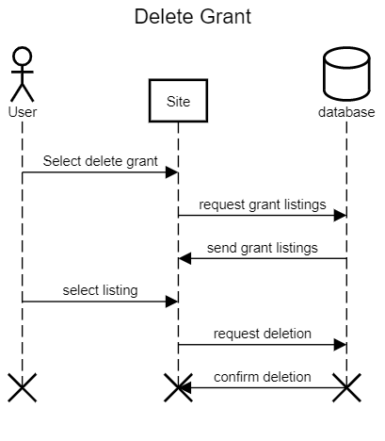

Use Case Specification: <Edit Announcement>

# Edit Announcement

## Brief Description

User edits a pre-existing announcement post

# Flow of Events

## Basic Flow

* User selects the edit announcement option in the administrative tab
* Select announcement from announcements list
* Enter announcement title
* Enter announcement text body
* Enter announcement post date
* Enter announcement post time
* Enter announcement automatic deletion date
* Submit
* Redirect to administrative tab
* Use case ends

# Special Requirements

# Pre-conditions

## Database containing announcement data is online

## Website is online

## User has administrative privileges

# Post-conditions

# Extension Points

Use Case Specification: <Edit Grant>

# Edit Grant

## Brief Description

User creates grant information posting

# Flow of Events

## Basic Flow

* Select Edit Grant from administrative tab
* Select from list of all grants
* Enter Grant title
* Enter grant issuer
* Enter grant Amount
* Enter grant description
* Enter grant application due date
* Submit
* Redirect to administrative tab
* Use case ends

## Alternative Flows

# Special Requirements

# Pre-conditions

## Website is online

## Grants database online

## User has administrative privileges

# Post-conditions

# Extension Points

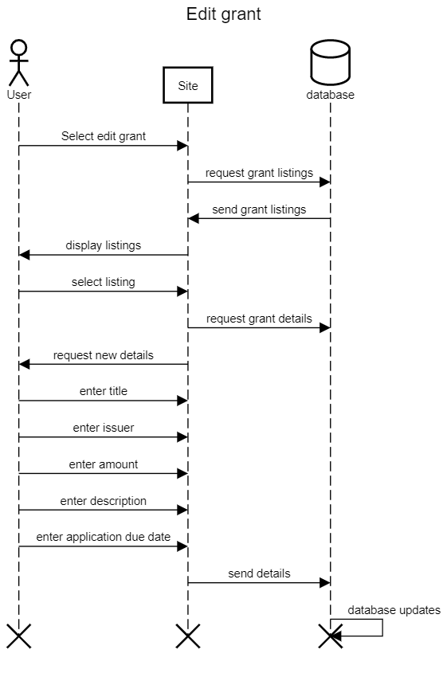

Use Case Specification: <Edit/Resend Newsletter post>

# Edit/Resend Newsletter post

## Brief Description

User will edit and resend updated newsletter. This will allow for users to make quick corrections to already sent newsletter posts

# Flow of Events

## Basic Flow

* Select Edit/Resend Newsletter from administrative tab
* Select pre-existing newsletter post from previous newsletters
* Enter title
* Enter text body
* Select send date
* Submit
* Use case ends

## Alternative Flows

# Special Requirements

# Pre-conditions

## User has administrative privileges

## Website is online

## Newsletter email database is online

## Website is online

# Post-conditions

# Extension Points

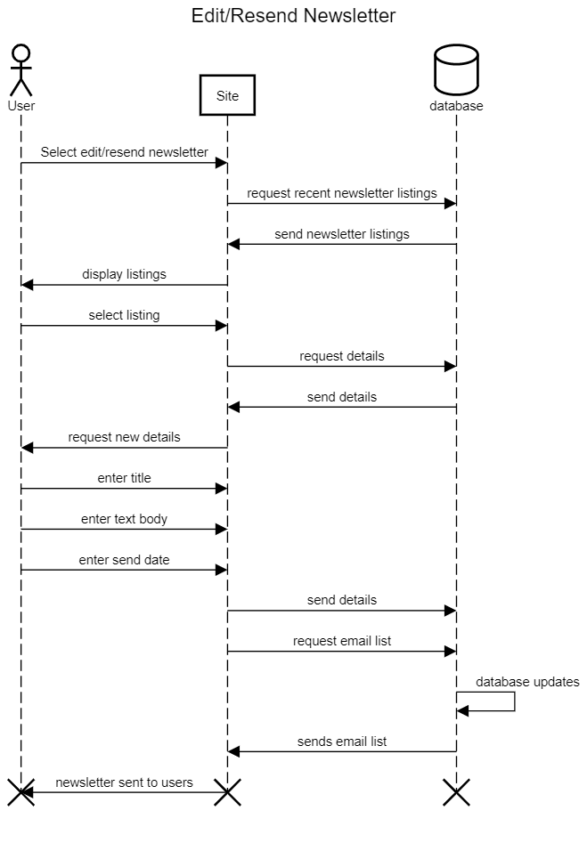

Use Case Specification: Search Contact Information

# Search Contact Information

## Brief Description

Users can select from a list of available contacts, grouped by department, or search with keywords to find the desired contact

# Flow of Events

## Basic Flow

* Select the contact tab on the home page
* Select desired contact from list of all contacts
* Select contact method
* Use Case ends

### **Keyword Search**

* Select the contact tab on the home page
* Arrive at contacts page
* Enter keyword into search bar
* Select from now curated list of contacts
* Arrive at specific contact page for the person selected
* Select contact method
* Use case ends

# Special Requirements

# Pre-conditions

## Database must be updated

## Database must be online

## System must be online

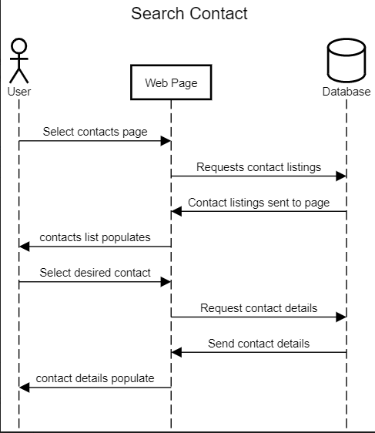

Use Case Specification: <Access Research Statistics>

# Access Research Statistics

## Brief Description

Users will search for reports pertaining to results of previous research projects

# Flow of Events

## Basic Flow

* User will select the research statistics page from the home directory
* Users will arrive at a page listing all projects with released information
* Users will select desired research project
* User will arrive at the project page
* Users will select from the reports available
* User will arrive at a page containing the report requested
* Use case ends

### **Alternative** **Flow**

* User will select the research statistics page from the home directory
* Users will arrive at a page listing all projects with released information
* Users will type keywords into the search bar
* Users will select desired research project
* User will arrive at the project page
* Users will select from the reports available
* User will arrive at a page containing the report requested
* Use case ends

# Special Requirements

## Research Result Database

# Pre-conditions

## System Online

## Database Online

## Database Updated

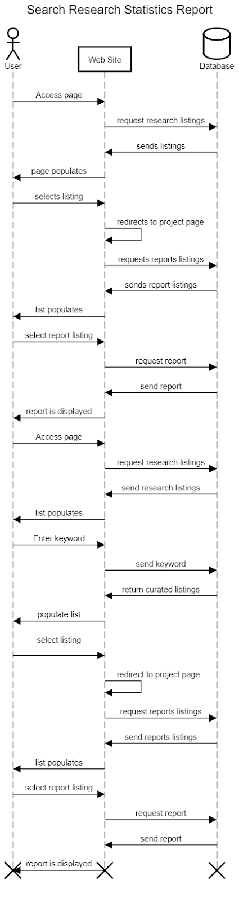

**Use Case: Create survey report**

Create survey report

This use case describes how users can create the survey reports.

**Basic Flow:**

* User select the survey reports option in research tab
* Enter survey title.
* Enter survey text
* Enter survey Dates
* Enter posted time
* Summit
* Survey created
* End use case

**Alternative flow:**

* User select the survey reports option in research tab
* User leave one field blank
* User summit
* Error message “Field cannot be blank”
* User field the blank
* User summit
* Message “Approve”

**System Requirement:**

Websites must be built in software and databases which allow users to edit the field.

**Pre-condition**

Users must have valid email to access the site.

**Post-Condition**

Survey is created.

**Use Case: Edit Survey report**

**Edit survey report**

This use case describes how users will edit survey reports.

**Basic Flow:**

* User click on create survey report in research tab
* User click on edit tab on the side of field
* Update or enter the new survey title
* Enter the new survey text
* Enter new survey Date
* Enter new survey time
* Summit
* Survey updated

**Alternative flow:**

* User clicks on create survey report in research tab
* User click on edit tab on the side of field
* User enter the new survey text
* User leave others field same
* User summit
* Error message “survey is not edited”
* User edit all the tab
* Message “survey edited”

**System Requirement:**

Websites must be built in software and databases which allow users to edit the field.

**Pre-Condition:**

Users must have the previous survey.

**Post-Condition:**

Survey is edited.

**Use Case: Delete survey report**

**Delete survey report**

This use case describes how users will delete survey reports that were posted by them and want to remove.

**Basic Flow:**

* User click on create survey report in research tab
* User clicks on the delete under the survey reports
* Message “Do you want to delete” Yes or No
* User click on yes
* Message “survey deleted”
* End use case

**Alternative Flow:**

* User click on create survey report in research tab
* User clicks on the delete under the survey reports
* Message “Do you want to delete” Yes or NO
* User clicks on No
* Survey remains same
* End use case

**System Requirement:**

Websites must be built in software and databases which allow users to edit the field.

**Pre-condition:**

There must be a survey already.

**Postcondition:**

survey deleted.

**Use Case: Login**

Login

This use case describes how users will login to the account.

**Basic Flow:**

* User goes to university of Louisville and innovation website
* User clicks on my account
* User enter user id
* User enter password
* Click summit
* End use case

**Alternative Flow:**

* User goes to university of Louisville and innovation website
* User clicks on my account
* User enter invalid id or password
* Error Message “wrong id or password”
* User enter valid id or password
* User clicks on login
* End use case

**System Requirement:**

Websites must have a built-in software/script that will allow users to login with secure and privacy.

**Pre-condition:**

User is not logged in to their account.

**Postcondition:**

User is logged in.

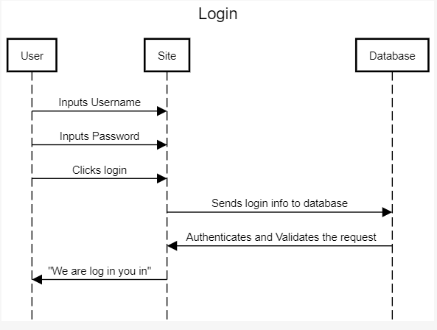

**Use Case: Logout**

Logout

This use case describe how users can logout from their account

**Basic Flow:**

* User goes to university of Louisville and innovation website
* User clicks on my account at the top right-hand
* User clicks on logout
* Message “Yes or No
* User click on Yes
* End use case

**Alternative Flow:**

* User goes to university of Louisville and innovation website
* User clicks on my account at the top right-hand
* User clicks on logout
* Message “Yes or No
* User clicks on No

**System Requirement:**

Website must have a built-in software/script that will allow user to login and out with secure and privacy

**Pre-condition:**

User should login already

**Postcondition:**

Logout from account

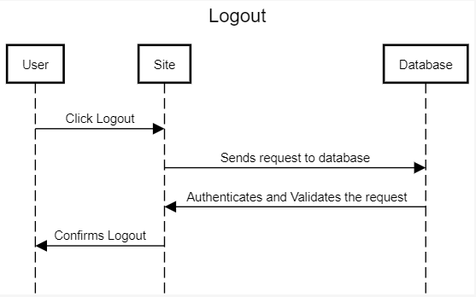

**Use Case: Create user profile**

Create user profile

This use case describe how users can create their user profile

**Basic Flow:**

* User goes to university of Louisville Research and Innovation website
* User click on home page
* User clicks down on create user profile
* User enter First Name, Last Name, Date of birth, Security Question in the field
* User enter user id
* User enter password
* User conform password
* User click on create my profile
* Message “successfully Created”
* End use case

**Alternative Flow:**

* User click on home page
* User clicks down on create user profile
* User enter First Name, Last Name, Date of birth, Security Question in the field
* User enter user id
* User enter password
* User conform password
* User missed to enter some information
* User click on create my profile
* Message “One or more field in not fill out”
* User fill all the required field
* Message “successfully Created”

**System Requirement:**

Website must have a built-in software/script that will allow user to login with secure and privacy

**Pre-Condition**

User profile was not created

**Post-Condition**

User profile created

**Use Case: Edit User profile**

Edit User profile

This use case describe how users can

**Basic Flow:**

* User click on home page
* User clicks on my Account
* User click on edit my profile
* User can edit First Name, Last Name, Date of birth, Security Question in the field
* User can edit user id
* User can edit password
* User click on create my profile
* Message “changed successfully”
* End use case

**Alternative Flow:**

* User click on home page
* User clicks on my Account
* User click on edit my profile
* User click on create user profile
* Message “No Changes”

**System Requirement:**

Websites must be built in software and databases which allow users to edit the field.

**Pre-condition:**

the user must have a profile and be able to login.

**Postcondition:**

User account

Use Case Specification: Contact UofL Office of Research and Innovation

1. **Contact UofL Office of Research and Innovation**
   1. **Brief Description**

This use case describes how Students and Visitors send emails directly to the University of Louisville Office of Research and Innovation through an embedded contact form.

1. **Flow of Events**
   1. **Basic Flow**

* User will click “About us” tab
* User clicks “Contact us” bar
* User enter “Subject”
* User enter “First Name”
* User enter “Last Name”
* User enter “Email”
* User enter “Phone”
* User enter “Message”
* User clicks “Send Email”
* Confirmation Box appears “Thank you! Your message has been successfully sent. We will contact you very soon!”

1. **Special Requirements**
   1. Website must have a built-in software/script that will be able to get emails in a secure and a private form.
2. **Pre-conditions**
   1. Senders must access UofL office of Research and innovation website’s form interface and have a valid personal email in which they can respond to.
3. **Post-Conditions**
   1. **Email Sent Successfully**

If the email was sent successfully a confirmation box appears with a message stating that it has been sent with a forwarded message to their personal email.

* 1. **Email wasn’t sent Successfully**

If the email wasn’t sent, an error box appears stating the reason or asking the user to try again later

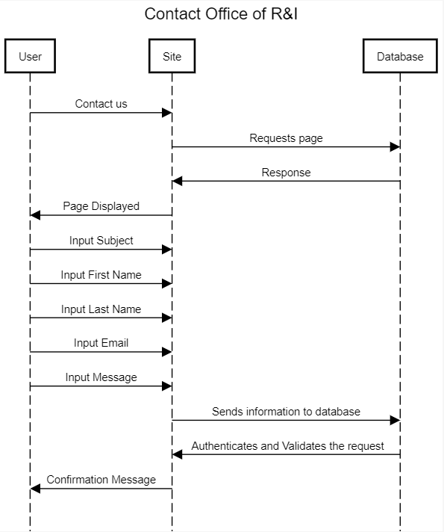

Use Case Specification: Edit Website

1. **Edit Website**
   1. **Brief Description**

This use case describes how UofL Office of Research and Innovation administrator’s will be editing the site

1. **Flow of Event**
   1. **Basic Flow**

* User Access UofL Office of Research and Innovation Home Page
* User Enters Username
* User Enters Password
* User clicks “Login”
* User gets directed administrator portal
* User views site sources
* User Edits Site Header
* User clicks “Save” button
* Site Message “Update Successful”

1. **Special Requirements**

Website must have a built-in software and database in order to edit the site.

1. **Pre-conditions**

User must be connected to the internet; user must be logged in and signed in as an administrator.

**4.1 Pre-conditions 1**

* User must be and administrator in Office of Research and Innovation Site.

**Post-Condition**

Website is updated successfully with the new requirement.

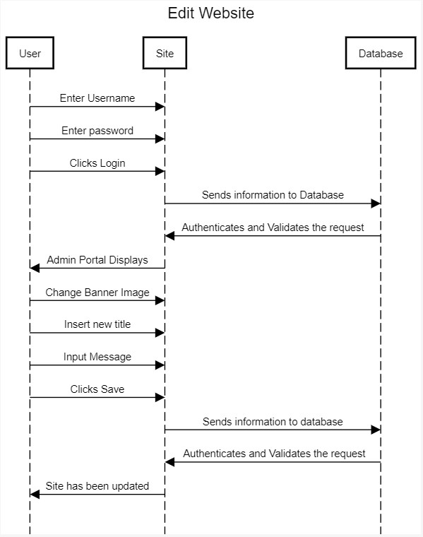

Use Case Specification: Look up applications

1. **Look up applications**
   1. **Brief Description**

This use case describes how Staff (Administrator) view students’ applications directly through the University of Louisville Office of Research and Innovation’s Website.

1. **Flow of Events**
   1. Basic Flow

* User Access UofL Office of Research and Innovation Home Page
* User Enters Username.
* User Enters Password.
* User clicks “Login”.
* User gets directed to the administrator portal.
* User clicks “View Pending Applications Tab”.
* User clicks “Recipients Application”.
* User clicks “Review Applications”
* User clicks “Approve” to accept recipient’s application

**2.2** **Alternative Flows**

* User Access UofL Office of Research and Innovation Home Page
* User Enters Username.
* User Enters Password.
* User clicks “Login”.
* User gets directed to the administrator portal.
* User clicks “View Pending Applications” Tab.
* User clicks “Students Application” bar from the tab.
* User clicks “Review Applications”
* User clicks “Deny” denying student’s application

1. **Special Requirement**
   1. **Staff Role**

User must have role to accept or deny recipients

1. **Pre-conditions**
   1. Internet Access, Staff role and Administrator permission is required to login to the admin portal
2. **Post-condition**
   1. **Denied or Accepted**

After staff Accepts an application an email will be sent to the recipient’s email address congratulating them on their acceptance. If a staff denies recipient application, an email will be sent with proper reason on why they have been denied.

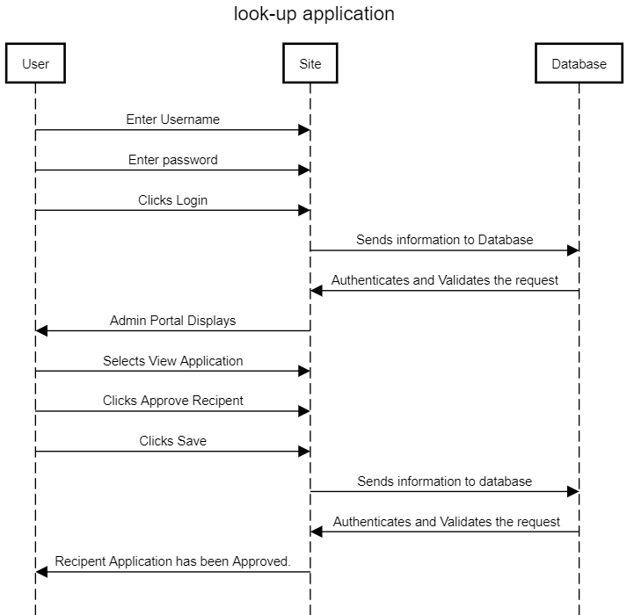

Use Case Specification: Look up events

1. **Look up Events**
   1. **Brief Description**

This use case describes how students, visitors and staff can look up the events on the University of Louisville Office of Research and Innovation’s Website.

1. **Flow of Events**
   1. **Basic Flow**

* User clicks “Search” from drop menu
* User Selects “Events”
* User Types in an event keyword in search bar.
* User Clicks “Search”
* User Clicks on event result
* User gets directed to the event.
  1. **Alternative Flow**
* User clicks “Search” from drop menu
* User Selects “Events”
* User Types in an unknow event title in the search bar.
* User Clicks “Search”
* Search Results Message “There are no matching”
* User types in a correct event keywork
* User Clicks “Search”
* User Clicks on event result
* User gets directed to the event.

1. **Special Requirements**

Database of upcoming, current and past events.

1. **Pre-conditions**

4.1

Internet Access is required, and user must be on UofL Office of R&I site.

1. **Post-condition**

5.1

User gets directed to the event once search result has been clicked.

Use Case Specification: Look up search history

1. **Look up search history**
   1. **Brief Description**

This use case describes how a user, visitor view search history on the University of Louisville Office of Research and Innovation’s Website.

1. **Flow of Events**
   1. **Basic Flow**

* User clicks on the “Search bar”
* Search history appears
  1. **Alternative Flows**
* User clicks on the “Search bar”
* Partial of search history appears.
* User enters a keyword.
* Search history with the specified keyword appears.

1. **Special Requirement**

3.1 Database, Script or software.

Database, script and or special software that can save visitors search history.

1. **Pre-condition**

User must have had few searches before viewing search history.

1. **Post-condition**

User’s search history appears

Use Case Specification: Look up grants

1. **Look up Grants**
   1. **Brief Description**

This use case describes how a student at the University of Louisville can look for grants using Office of Research and Innovation’s Website.

1. **Flow of Events**
   1. **Basic Flow**

* Student Clicks “Research Support” from the navigation.
* User clicks “Find Funding” option in the drop menu.
* User click “Federal Grants” user get directed to federal grants page
* List of all Federal agency’s grants appear
* User clicks on specified Grant Agencies.
* User gets directed to the site.
  1. **Alternative Flows**

1. **Special Requirement**

User must be a student at the UofL to be eligible for funds.

1. **Pre-condition**
   1. **Web Access**

Web access is required to access the Office of Research and Innovation’s Website.

* 1. **Grants availability**

Grants must be available in order to apply for.

1. **Post-condition**

**5.1 Grants Application Accepted**

Once a student gets directed to grants agencies site, if the students get the grants School must be notified by the agencies.

Use Case Specification: Browse Social Media

1. **Browse Social Media**
   1. Brief Description

The purpose of this case is to allow students and visitors to browse the University of Louisville Office of Research and Innovation’s Social Media.

1. **Flow of Events**
   1. **Basic Flow**

* User Scrolls until sees “Connect With:”
* User Clicks Facebook logo “F”
* User gets directed to Office of R&I Page
  1. **Alternative Flow**
     1. **Twitter**
* User Scrolls until sees “Connect With:”
* User Clicks Twitter logo.
* User gets directed to Office of R&I twitter Page
  1. **Alternative Flow**

2.2.2 **LinkedIn**

* User Scrolls until sees “Connect With:”
* User Clicks LinkedIn Logo “in”
* User gets directed to Office of R&I LinkedIn Page

1. **Special Requirements**
2. **Pre-conditions**
   1. **Web Access**

Web access is required to access the Office of Research and Innovation’s Website.

1. **Post-conditions**

**4.2 User Browse Social Media**

Once user clicks the preferred social media source, then the user can browse Office of R&I posts and status updates.

Use Case Specification: Follow Social Media

1. **Follow Social Media**
   1. **Brief Description**

The purpose of this case is to allow students and visitors to follow the University of Louisville Office of Research and Innovation’s on Social Media.

1. **Flow of Events**
   1. **Basic Flow**

* User Scrolls until sees “Connect With:”
* User Clicks Facebook logo “F”
* User gets directed to Office of R&I Page
* User will be asked to sign-in to Facebook
* User clicks “Like Page” to Follow the page on Facebook
  1. **Alternative Flow**

**2.2.1 Twitter**

* User Scrolls until sees “Connect With:”
* User Clicks Twitter logo.
* User gets directed to Office of R&I twitter Page
* User will be asked to sign-in Twitter
* User clicks “Follow” to follow the page on Twitter

**2.2.2 LinkedIn**

* User Scrolls until sees “Connect With:”
* User Clicks LinkedIn Logo “in”
* User gets directed to Office of R&I LinkedIn Page
* User will be asked to sign-in to LinkedIn
* User Clicks “Follow” to follow the page on LinkedIn

1. **Special Requirement** 
   1. **Social Media Account**

User must have an account in their preferred social media site that they would like to follow.

1. **Pre-condition**
   1. **Internet access**

Internet Access is required to access the Office of Research and Innovation’s Social media sites

* 1. **Valid Account**

Valid Social Media Account must exist before attempting to follow us on any social media account

1. **Post-condition**

Students and visitors can follow Office of Research and Innovation’s on Social Media for updates.

Use Case Specification: <Delete User Profile>

# Delete User Profile

## Brief Description

This use case describes how a user can delete their profile.

# Flow of Events

## Basic Flow

* Login to Research and Innovation Website
* Click on “Profile Settings”
* Click on “Delete Profile”
* Confirmation box appears: “Are you sure you want to delete your profile?”
* Click on “Yes”

**2.2 Alternate Flow**

* Login to Research and Innovation Website
* Click on “Profile Settings:
* Click on “Delete Profile”
* Confirmation box appears: “Are you sure you want to delete your profile?”
* Click on “No”
* Confirmation box disappears

# Special Requirements

# Pre-Conditions

## User has account

* 1. **User is logged into account**

# Post-Conditions

* 1. **User profile is deleted**

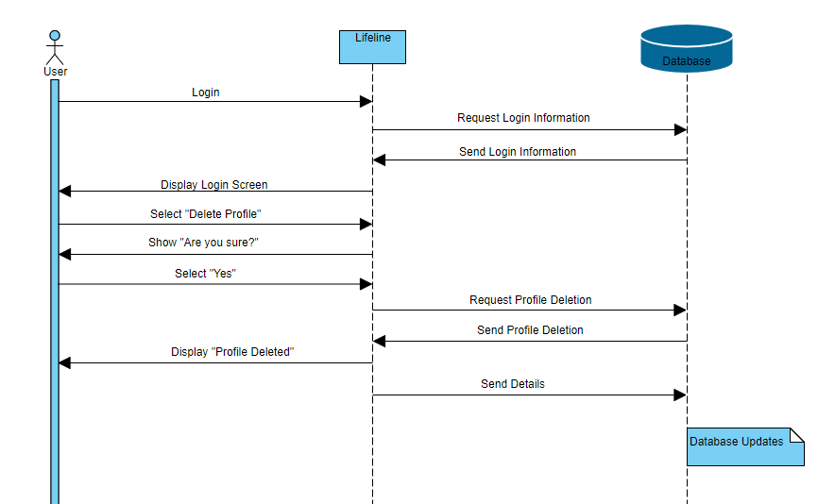

Use Case Specification: <Edit Rotating Banner>

# Edit Rotating Banner

## Brief Description

This use case describes how a website admin can edit the rotating banner.

# Flow of Events

## Basic Flow

* Login to admin account
* Go to main webpage
* Click the “Edit” button on the rotating banner.
* Click “Add” button
* Select which photo or video to add
* Click “Save”

**2.2 Alternate Flow**

* Login to admin account
* Go to main webpage
* Click the “Edit” button on the rotating banner.
* Click the “X” above a photo
* Click “Save”

# Special Requirements

# Pre-Conditions

## User is logged in

# Post-Conditions

**5.1 Banner has been updated with new photo or video**

**5.2 Banner has had**

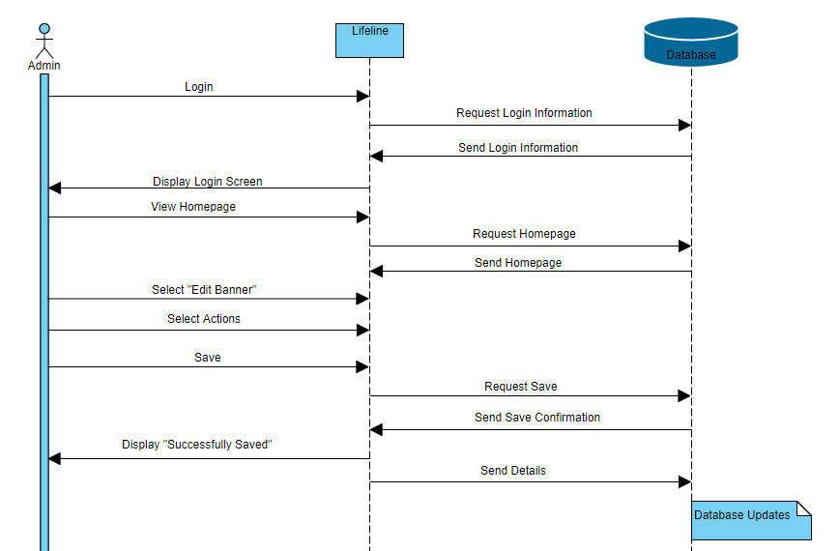

Use Case Specification: <Login to iRIS>

# Login to iRIS

## Brief Description

User creates announcement page to be displayed in the announcements list

# Flow of Events

## Basic Flow

* Hover over the tab for researchers
* Click on “Login to iRIS”
* Enter username
* Enter password
* Click “Login”

**2.2 Alternate Flow**

2.2.1 Incorrect Username or Password

* Hover over the tab for researchers
* Click on “Login to iRIS”
* Enter username
* Enter password
* Click “Login”
* Site Message: “Incorrect username or password”

2.2.1 Forgot Password

* Hover over the tab for researchers
* Click on “Login to iRIS”
* Click “Login Issues Link”
* Follow Prompts

# Special Requirements

# Pre-conditions

## User is logging into iRIS

# Post-conditions

**5.1 User is logged into iRIS**

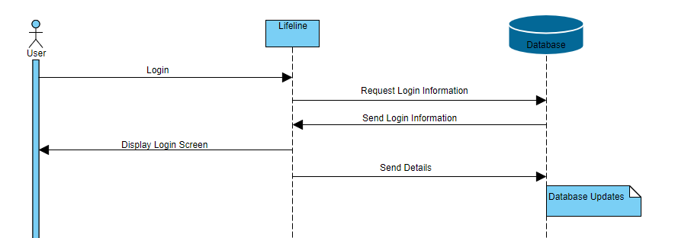

Use Case Specification: <Lookup Awards>

# Lookup Awards

## Brief Description

This use case describes how the user can find awards.

# Flow of Events

## Basic Flow

* Click on Search Bar
* Type in name of award
* Click on correct award

**2.2 Alternate Flow**

* Hover over the students tab
* Click on “Awards”

# Special Requirements

# Pre-Conditions

## Award data is updated correctly

# Post-Conditions

* 1. **Award information known**

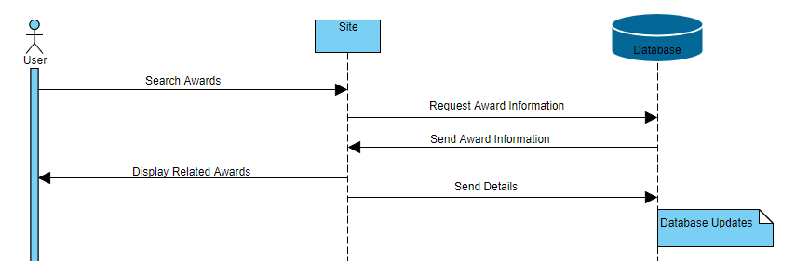

Use Case Specification: <Lookup Forms>

# Lookup Forms

## Brief Description

This use case describes how a user can lookup forms.

# Flow of Events

## Basic Flow

* Users scrolls over tabs depending on who they are.
* Click on “Forms” on the tab.
* Scroll through Form options

**2.2 Alternative Flow**

* Click on the Search Bar
* Type in the name of the form
* Click on form

# Special Requirements

# Pre-Conditions

## Correct forms are updated

* 1. **Forms are functioning**

# Post-Conditions

**5.1 Find information on Forms**

**5.2 Submit Form**

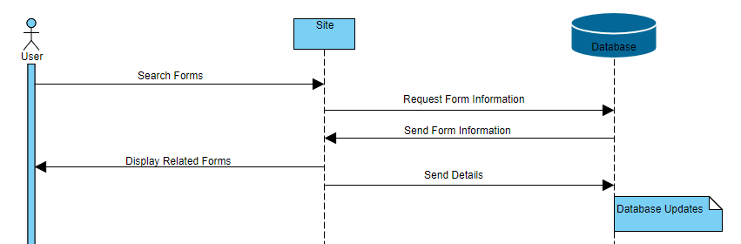

Use Case Specification: <Lookup Past Research>

# Lookup Past Research

## Brief Description

This use case describes how a user can lookup past research

# Flow of Events

## Basic Flow

* Scroll over tab for researchers
* Click on Past Research
* Scroll through past research

**2.2 Alternate Flow**

* Click on Search Bar
* Type in name of past research
* Click on past research

# Special Requirements

# Pre-Conditions

## Previous research is input

# Post-Conditions

* 1. **Leave with knowledge of past research**

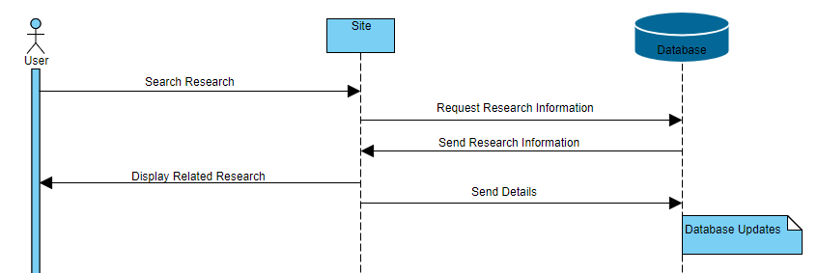

Use Case Specification: <Submit Industry Request Form>

# Submit Industry Request Form

## Brief Description

This use case describes how a user can submit an industry request form.

# Flow of Events

## Basic Flow

* Scroll over the “Industry” tab
* Click on “Forms”
* Click on “Industry Request Form”

**2.2 Alternate Flow**

* Click the Search Bar
* Type “Industry Request Form”
* Click on “Industry Request Form”

# Special Requirements

# Pre-Conditions

## Industry Request Form is working

# Post-Conditions

* 1. **Form was submitted**

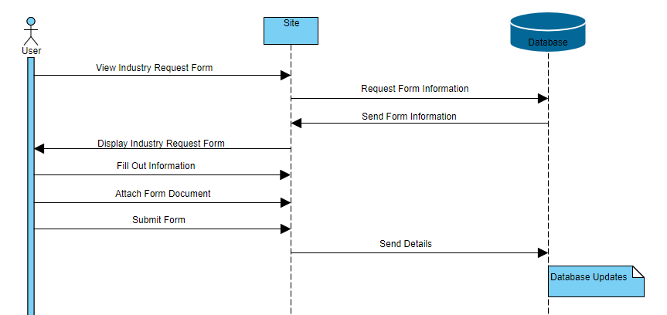

Use Case Specification: Accept Industry Proposal for UofL Office of Research and Innovation

**_____________________________________________________________________________________**

# Accept an Industry Proposal to the Office of Research and Innovation

## Brief Description

This use case describes how an Administrator accepts a proposal from a business/entity on the University Research and Innovation Website which creates an opportunity for students and industry to work together on a project.

# Flow of Events

## Basic Flow

* User will click “Industry” tab
* User clicks “View Proposals” button
* User reviews all data field containing info about the proposal (Ex. Company Name, Project Topic/Project Goals, etc.)
* User clicks “Accept” button
* Confirmation Box appears: “[Proposal Name] has been accepted!”

## Alternative Flows

### “Proposal is outside of University interests”

* User will click “Industry” tab
* User clicks “View Proposals” button
* User reviews all data field containing info about the proposal (Ex. Company Name, Project Topic/Project Goals, etc.)
* User finds error with proposal
* User clicks “Decline” button
* Confirmation Box appears: “[Proposal Name] has been Declined!”

### “Proposal does not fulfill all expectations of a proposal”

* User will click “Industry” tab
* User clicks “View Proposals” button
* User reviews all data field containing info about the proposal (Ex. Company Name, Project Topic/Project Goals, etc.)
* User finds that fields have been filled in incorrectly
* User clicks “Decline” button
* Confirmation Box appears: “[Proposal Name] has been Declined!”

# Special Requirements

## Website must have a form widget that allows for industries to submit proposals to the website for reviewing.

# Pre-conditions

## User must have administrative access to UofL office of Research and Innovation website

# Post-conditions

## *“Proposal is successfully accepted”*

If Proposal is successfully accepted user will receive a confirmation message box informing user that the proposal has been accepted and saved to the database.

5.2 *“Proposal is declined”*

If Proposal is declined user will receive an error message box informing user that the proposal has been declined and removed from the submissions database.

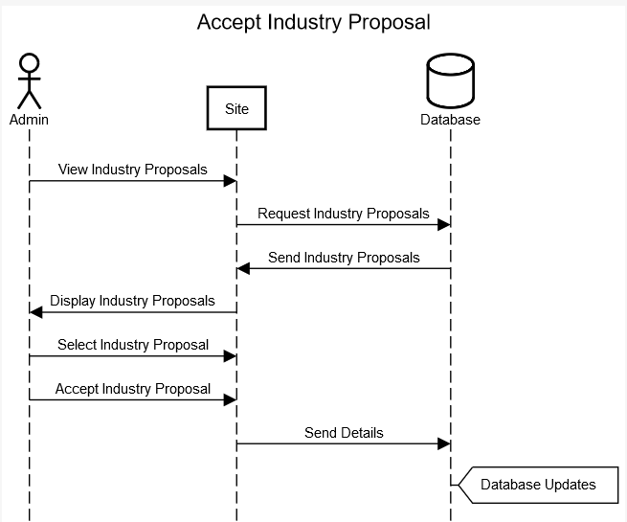

Use Case Specification: Delete Industry Proposal for UofL Office of Research and Innovation

**_____________________________________________________________________________________**

# Delete an Industry Proposal to the Office of Research and Innovation

## Brief Description

This use case describes how an Administrator deletes a proposal from a business/entity on the University Research and Innovation Website.

# Flow of Events

## Basic Flow

* User will click “Industry” tab
* User clicks “View Proposals” button
* User selects Proposal from list of proposals
* User clicks “Delete Proposal” button
* Message Box appears: “[Proposal Name] will be deleted, are you sure?”
* User clicks “Yes” Button
* Confirmation Box appears: “[Proposal Name] has been deleted!”

## Alternative Flows

### “User does not have permission to delete this proposal”

* User is signed into a personal account instead of Admin account
* User will click “Industry” tab
* User clicks “View Proposals” button
* User selects Proposal from list of proposals
* User clicks “Delete Proposal” button
* User receives Error Box: “You don’t have permission to access this function!”
* User signs into Administrative Account
* User will click “Industry” tab
* User clicks “View Proposals” button
* User selects Proposal from list of proposals
* User clicks “Delete Proposal” button
* Message Box appears: “[Proposal Name] will be deleted, are you sure?”
* User clicks “Yes” Button
* Confirmation Box appears: “[Proposal Name] has been deleted!”

# Special Requirements

## Website must have a form widget that allows for industries to submit proposals to the website and allows for proposals to be deleted by Administrator.

# Pre-conditions

## User must have administrative access to UofL office of Research and Innovation website

# Post-conditions

## *“Proposal is Successfully Deleted”*

If Proposal is successfully deleted user will receive a confirmation message box informing user that the proposal has been deleted from the proposal database.

5.2 *“Proposal isn’t Successfully Deleted”*

If Proposal isn’t successfully deleted user will receive an error message box informing user that the Proposal hasn’t been deleted and what caused the deletion of the Proposal to fail.

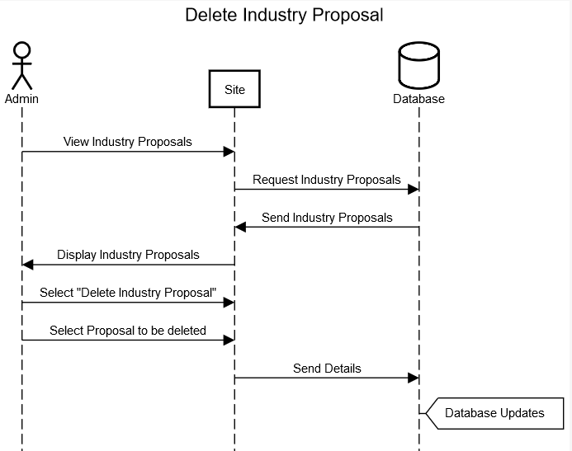

Use Case Specification: Edit Industry Proposal for UofL Office of Research and Innovation

**_____________________________________________________________________________________**

# Edit an Industry Proposal to the Office of Research and Innovation

## Brief Description

This use case describes how an Administrator edits a proposal from a business/entity on the University Research and Innovation Website which allows the user to interface with proposals and make necessary changes to them.

# Flow of Events

## Basic Flow

* User will click “Industry” tab
* User clicks “View Proposals” button
* User clicks “Edit Proposal” button
* User edits data field(s) of the proposal that need changing
* User clicks “Apply” button
* Confirmation Box appears: “[Proposal Name] has been edited!”

## Alternative Flows

### “Edited Proposal has a blank field”

* User will click “Industry” tab
* User clicks “Edit Proposals” button
* User edits data field(s) of the proposal that need changing
* User leaves a field blank
* User clicks “Apply” button
* Error Message appears: “Fields must contain valid data types only!”
* User fills in blank field
* Confirmation Box appears: “[Proposal Name] has been edited!”

# Special Requirements

## Website must have a form widget that allows for industries to submit proposals to the website and allows for proposals to be edited by Administrator.

# Pre-conditions

## User must have administrative access to UofL office of Research and Innovation website

# Post-conditions

## *“Proposal is successfully edited”*

If Proposal is successfully edited user will receive a confirmation message box informing user that the proposal has been edited and saved to the database.

5.2 *“Proposal edit cannot be applied”*

If Proposal edit throws an exception user will receive a error message box informing user that the proposal edit has been declined.

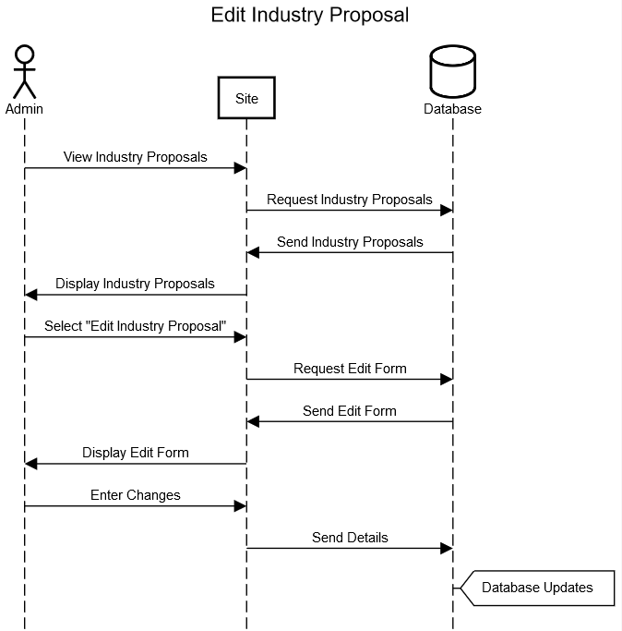

Use Case Specification: Create Statistic for UofL Office of Research and Innovation

**_____________________________________________________________________________________**

# Create a Statistic for Office of Research and Innovation Calendar

## Brief Description

This use case describes how an Administrator creates a statistic using data from the Department of Research and Innovation on the University of Louisville Office of Research and Innovation Website’s Statistic Widget on the Website Homepage.

# Flow of Events

## Basic Flow

* User will click on the Statistics Widget to expand widget
* User clicks “Add Statistic” button
* User enters the data for the desired statistic to be added into form which will format the info to appear in the widget
* User clicks “Create Statistic” button
* Confirmation Box appears: “Statistic has been successfully added!”

## Alternative Flows

### “Field(s) cannot be blank”

* User will click on the Statistics Widget to expand widget
* User clicks “Add Statistic” button
* User enters the data for the desired statistic to be added into form which will format the info to appear in the widget
* User leaves a field blank
* User clicks “Create Statistic” button
* Error Message appears: “No fields can be blank when editing a statistic!”
* User fills in blank field
* User clicks “Create Statistic” button
* Confirmation Box appears: “Statistic has been successfully added!”

### “Fields must contain correct data type”

* User will click on the Statistics Widget to expand widget
* User clicks “Add Statistic” button
* User enters the data for the desired statistic to be added into form which will format the info to appear in the widget
* User inputs invalid data type into a field (Ex. Letters in a number only field)
* User clicks “Create Statistic” button
* Error Message appears: Error Message appears: “Fields must contain valid data types only!”
* User replaces invalid data types with valid data types
* User clicks “Create Statistic” button
* Confirmation Box appears: “Statistic has been successfully added!”

# Special Requirements

## Website must have a statistic display widget to be able to create, edit, and store statistics.

# Pre-conditions

## User must have administrative access to UofL office of Research and Innovation website and new data to input for the statistic.

# Post-conditions

## *“Statistic is Successfully Created”*

If Statistic is successfully created user will receive a confirmation message box informing user that the statistic has been initialized and stored to the statistic widget.

## *“Statistic is not Created”*

If Statistic is unable to be created user will receive a error message box informing user why the Statistic could not be created.

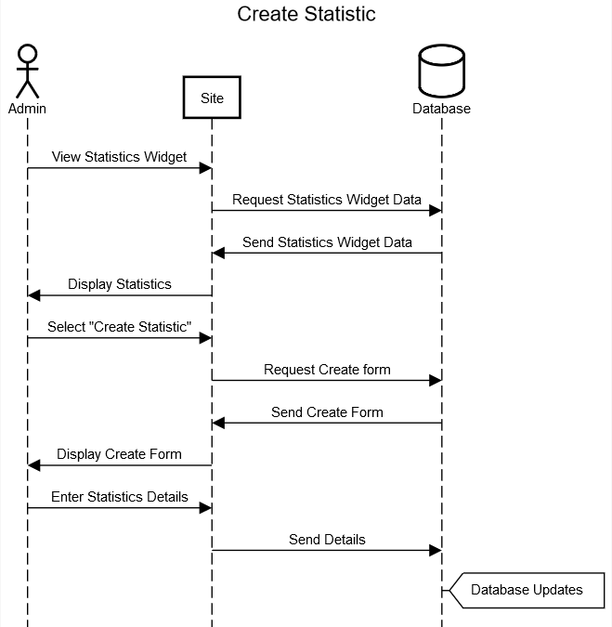

Use Case Specification: Delete Statistic for UofL Office of Research and Innovation

**_____________________________________________________________________________________**

# Delete a Statistic for Office of Research and Innovation Statistic Widget

## Brief Description

This use case describes how an Administrator Deletes a Statistic on the integrated Statistic Widget on the University Research and Innovation Website.

# Flow of Events

## Basic Flow

* User will click on the Statistics Widget to expand widget
* User clicks “Delete Statistic” button
* User selects a Statistic from the Widget
* User clicks “Delete” button
* Confirmation Box appears: “Are you sure you want to delete this statistic?”
* User clicks “Confirm” button
* Confirmation Box appears: “Statistic has been successfully deleted!”

## Alternative Flows

### “User does not have permission to delete this event”

* User is signed into a personal account instead of Admin account
* User will click on the Statistics Widget to expand widget
* User clicks “Delete Statistic” button
* User selects Statistic to be deleted
* User selects “Delete” Button
* User receives Error Box: “You don’t have permission to access this function!”
* User signs into Administrative Account
* User will click on the Statistics Widget to expand widget
* User clicks “Delete Statistic” button
* User selects Statistic to be deleted
* User selects “Delete” Button
* Confirmation Box appears: “Are you sure you want to delete this statistic?”
* User clicks “Confirm” button
* Confirmation Box appears: “Statistic has been successfully deleted!”

# Special Requirements

## Website must have a statistic display widget to be able to create, edit, and store statistics.

# Pre-conditions

## User must have administrative access to UofL office of Research and Innovation website

# Post-conditions

## *“Statistic is Successfully Deleted”*

If Statistic is successfully Deleted user will receive a confirmation message box informing user that the statistic has been deleted from the Statistic Widget.

5.2 *“Statistic isn’t Successfully Deleted”*

If Statistic isn’t successfully deleted user will receive an error message box informing user that the Statistic hasn’t been deleted and what caused the deletion of the Statistic to fail.

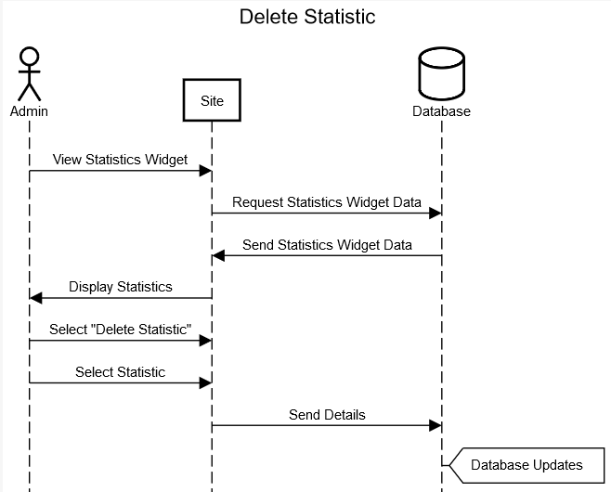

Use Case Specification: Edit Statistic for UofL Office of Research and Innovation

**_____________________________________________________________________________________**

# Edit a Statistic for Office of Research and Innovation Calendar

## Brief Description

This use case describes how an Administrator edits a statistic on the University of Louisville Office of Research and Innovation Website’s Statistic Widget on the Website Homepage.

# Flow of Events

## Basic Flow

* User will click on the Statistics Widget to expand widget
* User clicks “Edit Statistic” button
* User changes desired field containing info about the event (Ex. Name, Time/Place, etc.)
* User clicks “Confirm Changes” button
* Confirmation Box appears: “Statistic has been successfully edited!”

## Alternative Flows

### “Field(s) cannot be blank”

* User will click on the Statistics Widget to expand widget
* User clicks “Edit Statistic” button
* User changes desired field containing info about the Statistic
* User leaves a field blank
* User clicks “Confirm Changes” button
* Error Message appears: “No fields can be blank when editing a statistic!”
* User fills in blank field
* User clicks “Confirm Changes” button
* Confirmation Box appears: “Statistic has been successfully edited!”

### “Fields must contain correct data type”

* User will click on the Statistics Widget to expand widget
* User clicks “Edit Statistic” button
* User changes desired field containing info about the Statistic
* User inputs invalid data type into a field (Ex. Letters in a number only field)
* User clicks “Confirm Changes” button
* Error Message appears: “Fields must contain valid data types only!”
* User replaces invalid data types with valid data types
* User clicks “Confirm Changes” button
* Confirmation Box appears: “Statistic has been successfully edited!”

# Special Requirements

## Website must have a statistic display widget to be able to create, edit, and store statistics.

# Pre-conditions

## User must have administrative access to UofL office of Research and Innovation website and new data to input for the statistic.

# Post-conditions

## *“Statistic is Successfully Edited”*

If Statistic is successfully edited user will receive a confirmation message box informing user that the statistic has been edited and stored to the statistic widget.

## *“Statistic can’t be Edited”*

If Statistic is unable to be edited user will receive a error message box informing user why the Statistic could not be edited.

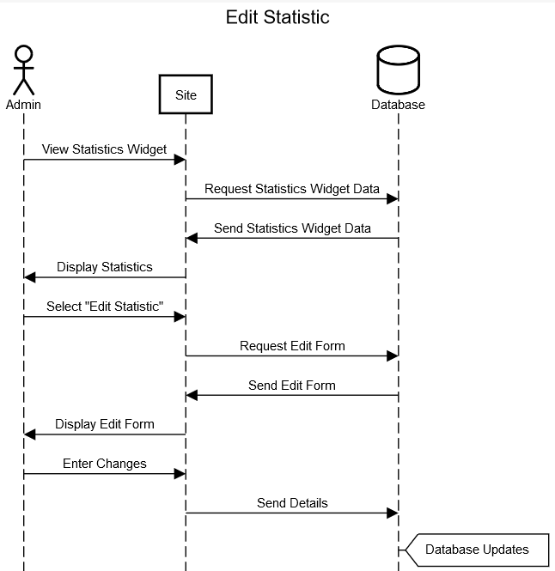

Use Case Specification: Apply for Grant through UofL Office of Research and Innovation

**_____________________________________________________________________________________**

# Apply for a Grant through the Office of Research and Innovation

## Brief Description

This use case describes how a user applies for a Grant through the University Research and Innovation Website to help fund an academic project.

# Flow of Events

## Basic Flow

* User will click “Grant” tab
* User clicks “Apply for Grant” button
* User fills all required data fields for Grant Application (Ex. Name, Status (Student, Teacher, etc.))
* User clicks “Apply” button
* Confirmation Box appears: “[Username] has applied for [Grant Name]”

## Alternative Flows

### “Field(s) cannot be blank”

* User will click “Grant” tab
* User clicks “Apply for Grant” button
* User fills all required data fields for Grant Application
* User leaves a field blank
* User clicks “Apply” button
* Error Message appears: “No fields can be blank when applying for Grant!”
* User fills in blank field
* User clicks “Apply” button
* Confirmation Box appears: “[Username] has applied for [Grant Name]”

# Special Requirements

## Website must have a form widget that allows for users to apply for Grants on the website for reviewing by Administrators.

# Pre-conditions

## User must have access to UofL office of Research and Innovation website

# Post-conditions

## *“Grant is Successfully applied for”*

If Grant is successfully applied for user will receive a confirmation message box informing user that the application has been submitted and saved to the database.

5.2 *“Grant Application fails”*

If application is declined user will receive an error message box informing user that the application has been declined and the reason for being declined.

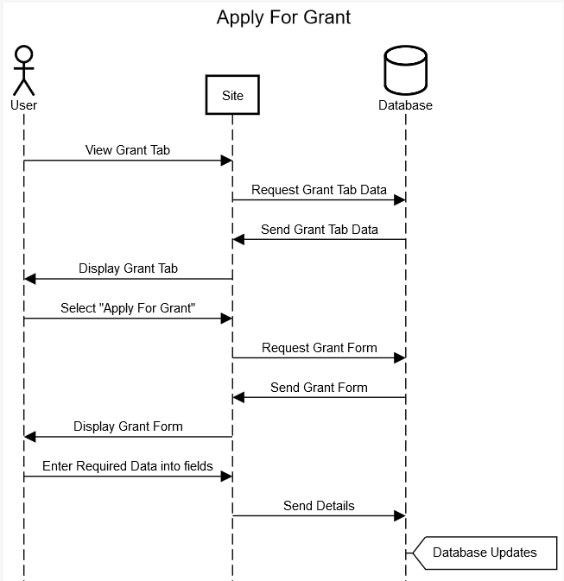

Use Case Specification: Apply for Newsletter of UofL Office of Research and Innovation

**_____________________________________________________________________________________**

# Apply for the Newsletter of the Office of Research and Innovation

## Brief Description

This use case describes how a user applies for updates through the official Newsletter of the University Research and Innovation Website.

# Flow of Events

## Basic Flow

* User will click “Newsletter” tab
* User clicks “Apply for Newsletter” button
* User fills all required data fields for Newsletter Application (Ex. Name, Contact info, etc.)
* User clicks “Apply” button
* Confirmation Box appears: “[Username] has applied for the Official UofL Research and Innovation Newsletter”

## Alternative Flows

### “Field(s) cannot be blank”

* User will click “Newsletter” tab
* User clicks “Apply for Newsletter” button
* User fills all required data fields for Newsletter Application
* User leaves a field blank
* User clicks “Apply” button
* Error Message appears: “No fields can be blank when applying for Newsletter!”
* User fills in blank field
* User clicks “Apply” button
* Confirmation Box appears: “[Username] has applied for the Official UofL Research and Innovation Newsletter”

# Special Requirements

## Website must have a Newsletter widget that allows for users to apply for updates from the Newsletter on the website.

# Pre-conditions

## User must have access to UofL office of Research and Innovation website

# Post-conditions

## *“Application is Successful”*

If Application is successful, user will receive a confirmation message box informing user that they will now receive notifications from the Office of Research and Innovation.

5.2 *“Application fails”*

If Application is declined user will receive an error message box informing user that the application has been declined and the reason for being declined.

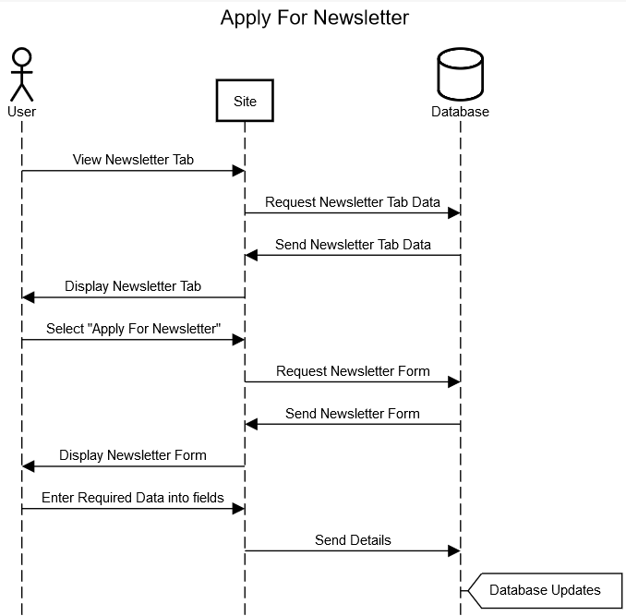

Use Case Specification: Submit Proposal for UofL Office of Research and Innovation

**_____________________________________________________________________________________**

# Submit a Proposal to the Office of Research and Innovation

## Brief Description

This use case describes how a professor submits a proposal to the University Research and Innovation Website which creates an opportunity for students and professors to work together on a project.

# Flow of Events

## Basic Flow

* User will click “Faculty” tab
* User clicks “Submit Proposals” button
* User fills all data field containing info about the proposal (Ex. Professor Name, Project Topic/Project Goals, etc.)
* User clicks “Submit” button
* Confirmation Box appears: “[Proposal Name] has been submitted!”

## Alternative Flows

### “Field(s) cannot be blank”

* User will click “Faculty” tab
* User clicks “Submit Proposals” button
* User fills all data field containing info about the proposal
* User leaves a field blank
* User clicks “Submit” button
* Error Message appears: “No fields can be blank when submitting a proposal!”
* User fills in blank field
* User clicks “Submit” button
* Confirmation Box appears: “[Proposal Name] has been submitted!”

# Special Requirements

## Website must have a form widget that allows for professors to submit proposals to the website for reviewing.

# Pre-conditions

## User must have access to UofL office of Research and Innovation website

# Post-conditions

## *“Proposal is successfully accepted”*

If Proposal is successfully accepted user will receive a confirmation message box informing user that the proposal has been accepted and saved to the database.

5.2 *“Proposal is declined”*

If Proposal is declined user will receive a confirmation message box informing user that the proposal has been declined and removed from the submissions database.

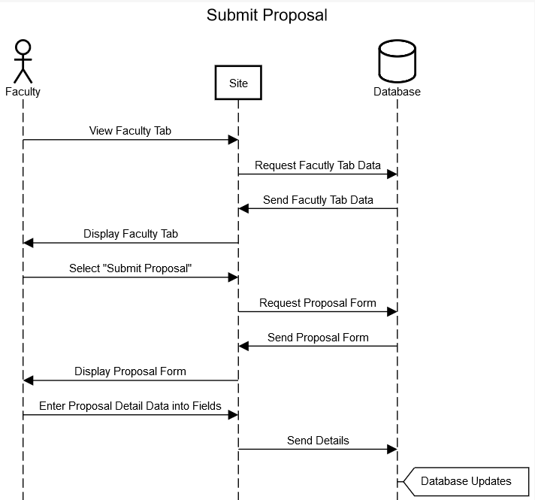

Class Diagram

The follow diagram shows the class structure of the system to be implemented. It details the different classes and their respective attributes and methods. The attributes are the data that will be stored. The methods are the operations that can take place with that specific class. Diagram 1 was mainly built using prototype analysis. By looking at the prototypes, we were able to create the respective class structure necessary. Most of this diagram revolves around administrators and their abilities to manage different classes. It also features the users and what they can do in the system.



Diagram 1

Database Design and Data Definitions

The following diagram shows the database design for the system to be implemented. This involved taking the class diagram and cutting some of it down to eliminate any repetition and other related flaws. Most of the data will be stored as strings with relatively small character counts. Some of the attributes will have to support high character counts though, as there are some that will contain paragraphs.



Diagram 2

Date Descriptions

The following tables provide an overview of the different attributes for each entity. This includes the name of each attribute, its description, size, type, and whether it is a primary key, foreign key, or none. This provides database designers with the adequate information that they need to create the database tables and fields.

|  |  |  |  |  |
| --- | --- | --- | --- | --- |
| **Research** | | | | |
| Name | Defintion | Size | Type | PK/FK |
| ResearchID | Unique identifier | 2 | Int | PK |
| Name | Name of the research | 30 | Varchar |  |
| Date | Date of the research | 10 | Date |  |
| Location | Location of the research | 30 | Varchar |  |
| Researchers | Researchers involved | 30 | Varchar |  |
|  |  |  |  |  |
| **Awards** | | | | |
| Name | Defintion | Size | Type | PK/FK |
| AwardID | Unique identifier | 2 | Int | PK |
| Name | Name of award | 30 | Varchar |  |
| Date | Date of award | 10 | Date |  |
| Recipient | Recipient of award | 30 | Varchar |  |
|  |  |  |  |  |
| **Forms** | | | | |
| Name | Defintion | Size | Type | PK/FK |
| FormID | Unique identifier | 2 | Int | PK |
| Name | Name of form | 30 | Varchar |  |
| Description | Description of form | 150 | Varchar |  |
| UploadDate | Upload date of form | 10 | Date |  |
| Location | Location of form | 30 | Varchar |  |
|  |  |  |  |  |
| **Banner** | | | | |
| Name | Defintion | Size | Type | PK/FK |
| BannerID | Unique identifier | 2 | Int | PK |
| Title | Title of banner | 30 | Varchar |  |
| PostDate | Post date of banner | 10 | Date |  |
| EndDate | End date of banner | 10 | Date |  |
|  |  |  |  |  |
| **News** | | | | |
| Name | Defintion | Size | Type | PK/FK |
| NewsID | Unique identifier | 2 | Int | PK |
| Name | Name of news | 30 | Varchar |  |
| Date | Date of news | 10 | Date |  |
| Time | Time of news | 10 | Time |  |
| Title | Title of news | 30 | Varchar |  |
| Description | Description of news | 150 | Varchar |  |
|  |  |  |  |  |
| **Calendar** | | | | |
| Name | Defintion | Size | Type | PK/FK |
| CalendarID | Unique identifier | 2 | Int | PK |
| Date | Date on calendar | 10 | Date |  |
| Events | Events on the calendar | 30 | Varchar |  |
|  |  |  |  |  |
| **Announcement** | | | | |
| Name | Defintion | Size | Type | PK/FK |
| AnnouncementID | Unique identifer | 2 | Int | PK |
| Title | Title of announcement | 30 | Varchar |  |
| Body | Body of the announcement | 250 | Varchar |  |
| SendDate | The date of announcement to be sent | 10 | Date |  |
|  |  |  |  |  |
| **GrantApplication** | | | | |
| Name | Defintion | Size | Type | PK/FK |
| GrantApplicationID | Unique identifier | 2 | Int | PK |
| Username | Usernam enters on application | 30 | Varchar |  |
| Email | Email of user | 30 | Varchar |  |
| GrantName | Name of the grant | 30 | Varchar |  |
| Occupation | Occupation of applicant | 30 | Varchar |  |
|  |  |  |  |  |
| **User** | | | | |
| Name | Defintion | Size | Type | PK/FK |
| UserID | Unique identifier | 2 | Int | PK/FK |
| Password | User password | 30 | Varchar |  |
| FirstName | First name of user | 30 | Varchar |  |
| LastName | Last name of user | 30 | Varchar |  |
| Email | User email | 30 | Varchar |  |
| SecQuestion1 | Sec question1 for user | 30 | Varchar |  |
| SecQuestion2 | Sec question2 for user | 30 | Varchar |  |
| SecQuestion3 | Sec question3 for user | 30 | Varchar |  |
|  |  |  |  |  |
| **Administrator** | | | | |
| Name | Defintion | Size | Type | PK/FK |
| AdminID | Unique identifier | 2 | Int | PK/FK |
| Username | Admin username | 30 | Varchar |  |
| Password | Admin password | 30 | Varchar |  |
| FirstName | Admin firstname | 30 | Varchar |  |
| LastName | Admin lastname | 30 | Varchar |  |
| Email | Admin email | 30 | Varchar |  |
|  |  |  |  |  |
| **CoreFacilities** | | | | |
| Name | Defintion | Size | Type | PK/FK |
| FacilityID | Unique identifier | 2 | Int | PK |
| CoreFacility | Name of core | 30 | Varchar |  |
| SpecificFacility | Name of specific facility | 30 | Varchar |  |
|  |  |  |  |  |
| **Survey** | | | | |
| Name | Defintion | Size | Type | PK/FK |
| SurveyID | Unique identifier | 2 | Int | PK |
| Title | Title of survey | 30 | Varchar |  |
| SurveyInfo | Information on the survey | 30 | Varchar |  |
| QuestionType | Type of question on survey | 30 | Varchar |  |
| SurveyQuestion | The survey question | 30 | Varchar |  |
| Selection | The selection for the question | 30 | Varchar |  |
|  |  |  |  |  |
| **NewsletterApplication** | | | | |
| Name | Defintion | Size | Type | PK/FK |
| NewsletterApplicationID | Unique identifier | 2 | Int | PK |
| Name | Name of applicant | 30 | Varchar |  |
| Email | Email of applicant | 30 | Varchar |  |
|  |  |  |  |  |
| **RSVP** | | | | |
| Name | Defintion | Size | Type | PK/FK |
| RSVPID | Uniqe identifier | 2 | Int | PK/FK |
| AttendanceDate | Date attendant will go to event | 10 | Date |  |
|  |  |  |  |  |
| **Newsletter** | | | | |
| Name | Defintion | Size | Type | PK/FK |
| NewsletterID | Unique identifier | 2 | Int | PK/FK |
| Title | Title of newsletter | 30 | Varchar |  |
| Body | Body of the newsletter | 500 | Varchar |  |
| PostDate | Date the newsletter will post | 10 | Date |  |
| DeleteDate | Date the newsletter will delet | 10 | Date |  |
|  |  |  |  |  |
| **Event** | | | | |
| Name | Defintion | Size | Type | PK/FK |
| EventID | Unique identifier | 2 | Int | PK/FK |
| Title | Title of event | 30 | Varchar |  |
| Date | Date of the event | 10 | Date |  |
| Start | Start time of the event | 10 | Time |  |
| End | End time of the event | 10 | Time |  |
| Address | Addres of the event | 30 | Varchar |  |
| City | City event will be in | 30 | Varchar |  |
| State | State event will be in | 2 | Char |  |
| Zipcode | Zipcode of event | 2 | Int |  |
| Info | Info about the event | 30 | Varchar |  |
|  |  |  |  |  |
| **Grant** | | | | |
| Name | Defintion | Size | Type | PK/FK |
| GrantID | Unique identifier | 2 | Int | PK/FK |
| Title | Title of the grant | 30 | Varchar |  |
| Amount | Amount of the grant | 4 | Int |  |
| Issuer | Issuer of the grant | 30 | Varchar |  |
| Description | A description of the grant | 30 | Varchar |  |
| DueDate | Due date of the grant | 10 | Date |  |

User Interface Navigation Diagram

The following diagram depicts the screens needed when interacting with the system. This is a helpful diagram that maps out all the routes users will take when using the system.



Screen Layouts

Layout 1 below shows what an administrator might wee when creating, editing, or deleting a survey. The form offers many different types of questions, as well as a button to add more questions. The administrator basically has free range to go in and put whatever they need into the survey.



Layout 1

Layout 2 below shows what an administrator might see when creating an event. There are text boxes used to enter in event information. There is also a calendar that can be used to select the date. This will help with validation and make it a bit easier to select the date. There is also a section to add any relevant pictures that will show up in the events widget.



Layout 2

Layout 3 below shows what an administrator might see when editing and deleting an event. The first widget is used to quickly delete an event by clicking the ‘x’ button on the right-hand side of each event. The other symbol is used to edit an event. It will let the administrator edit the event title. The second image is the event editor. It is a more detailed editor that lets the administrator make sweeping changes to an event.



Layout 3

Layout 4 below is what a user would see if they were to fill out an industry request form. This is nearly identical to the existing IR form that exists on the site now. It didn’t need much changing.



Layout 4

Layout 5 below shows how users can RSVP for an event as well as cancel for an event. If logged in, the user will simply click RSVP and that is it. The button will switch to say cancel to give them that option in the future. If the user has no account, they will be prompted to enter some information so that they can be added as an event attendee.



Layout 5

Create announcement

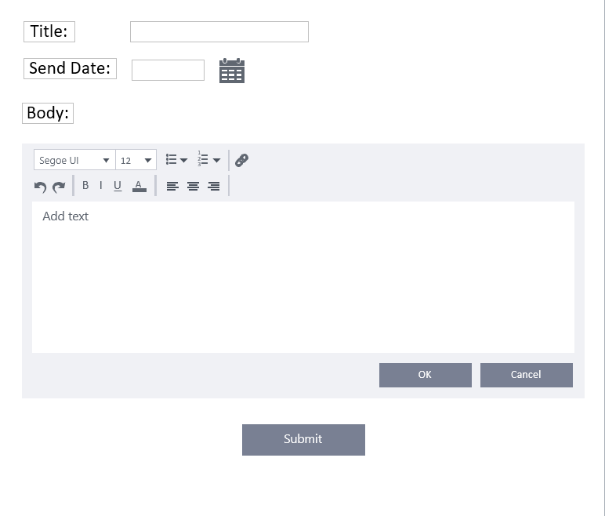

Layout 6

Create Grant

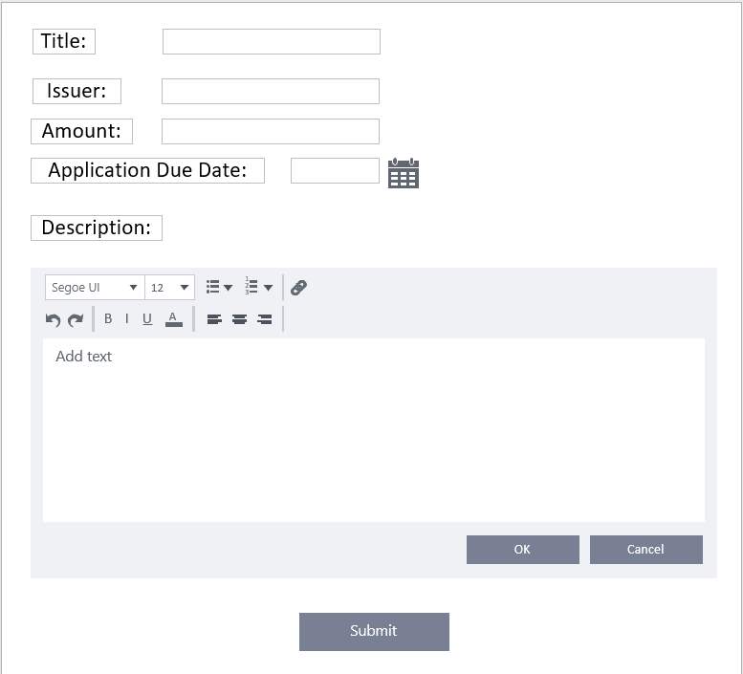

Layout 7

Create Newsletter

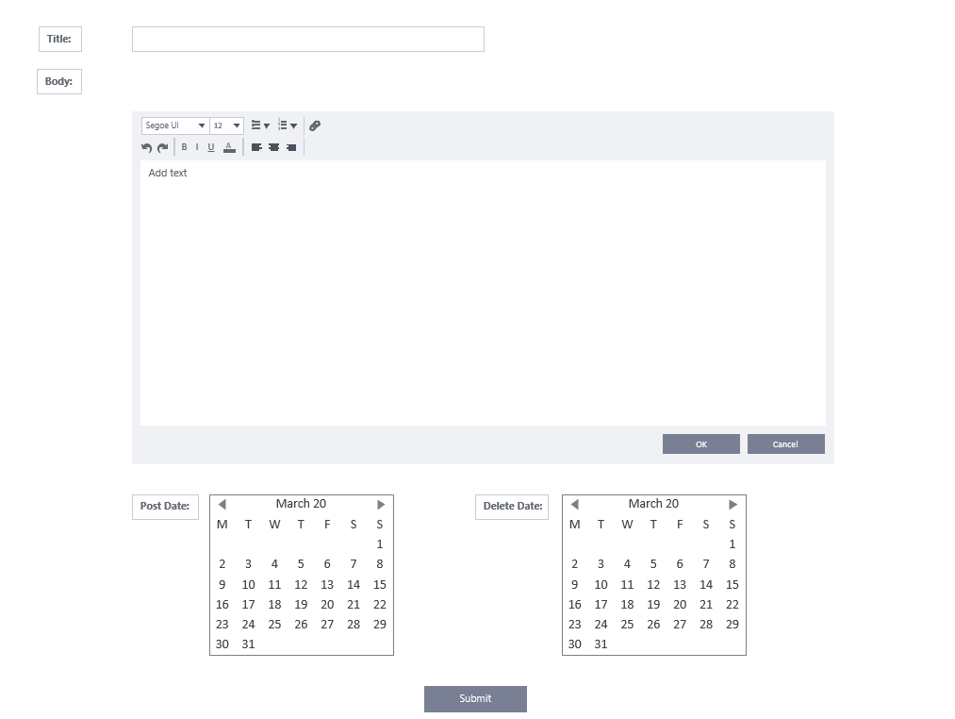

Layout 8

Create user profile

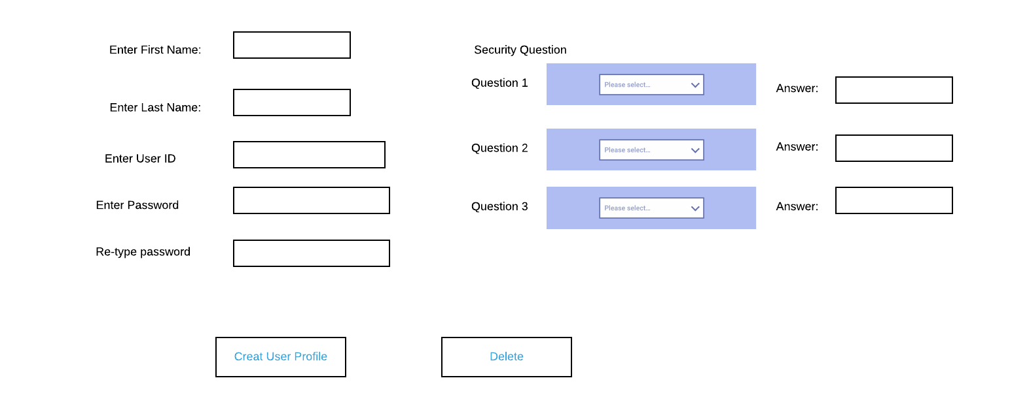

Layout 9

This prototype demonstrates the contact us form that students and visitors can use to contact the Office of Research and Innovation.

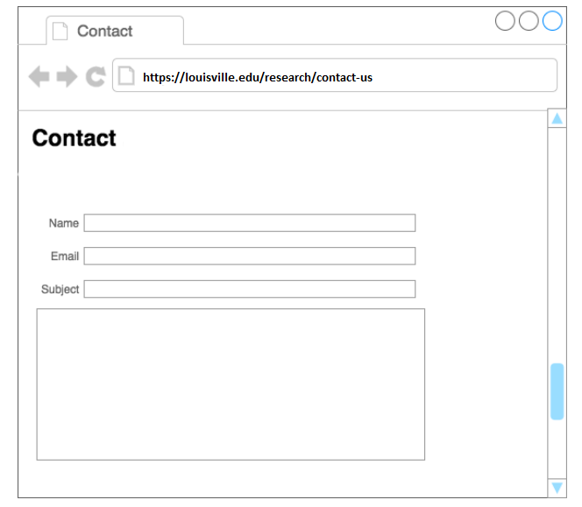

Layout 10

This Prototype demonstrates what an administrator interface looks like when accessing the admin portal.

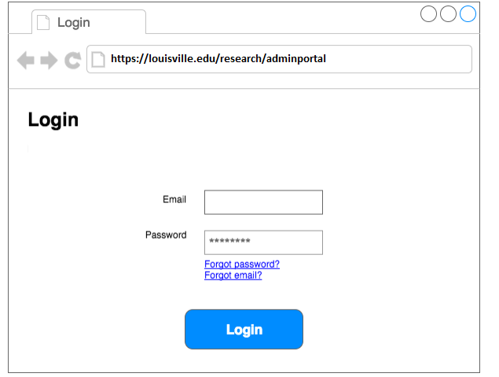

Layout 11

Submit Proposal

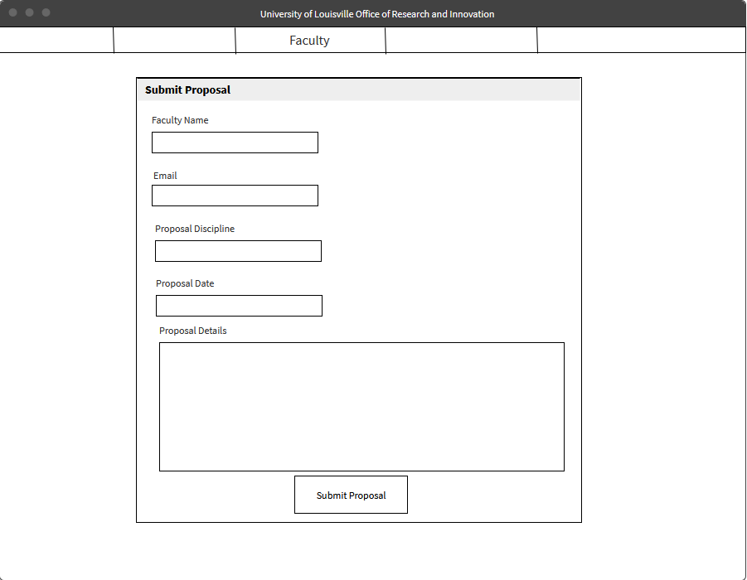

Layout 12

Statistics Interface

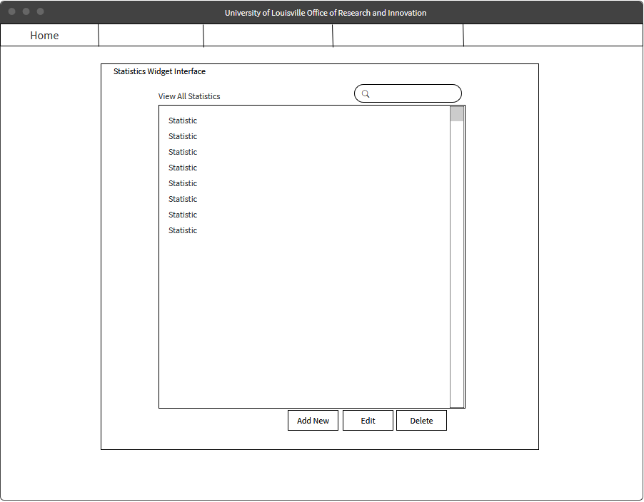

Layout 13

Edit Statistic

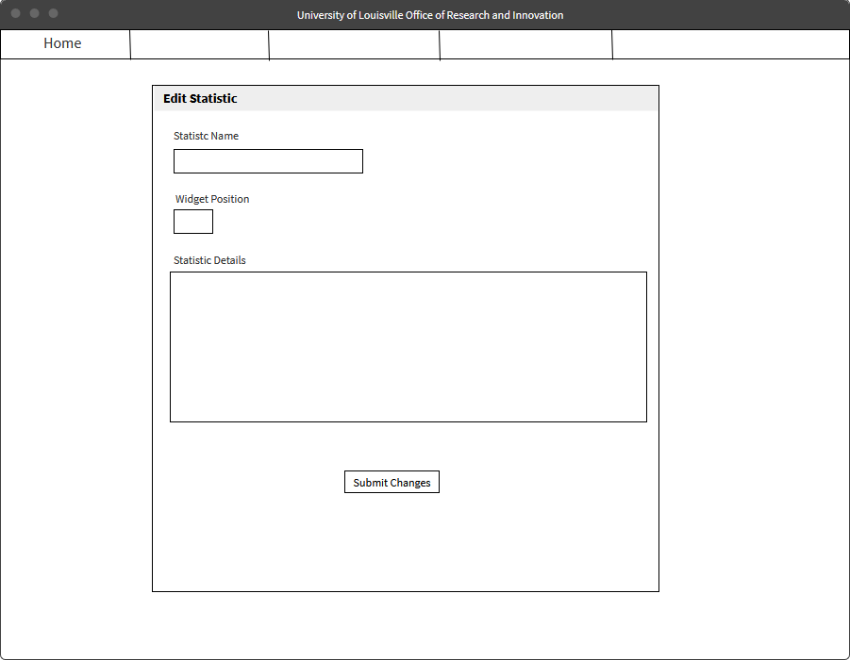

Layout 14

Edit Industry Proposal

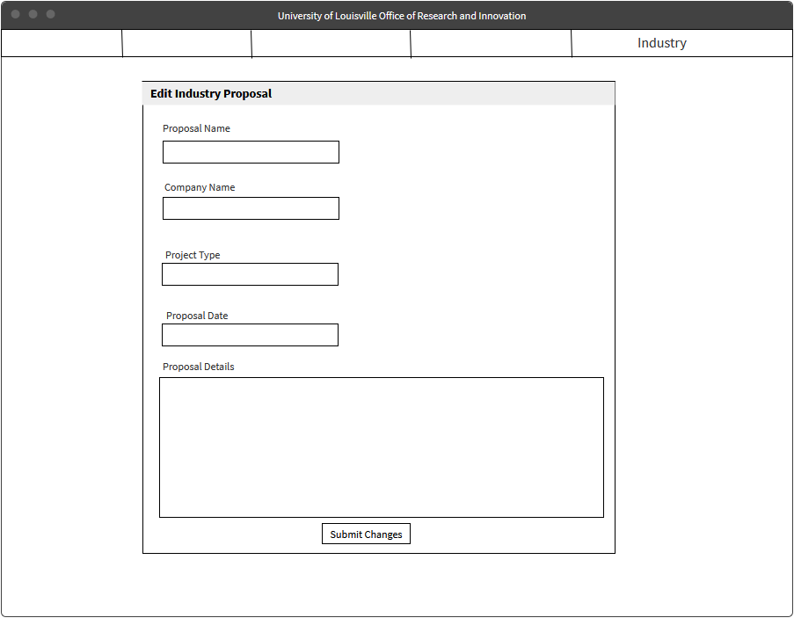

Layout 15

Apply for newsletter

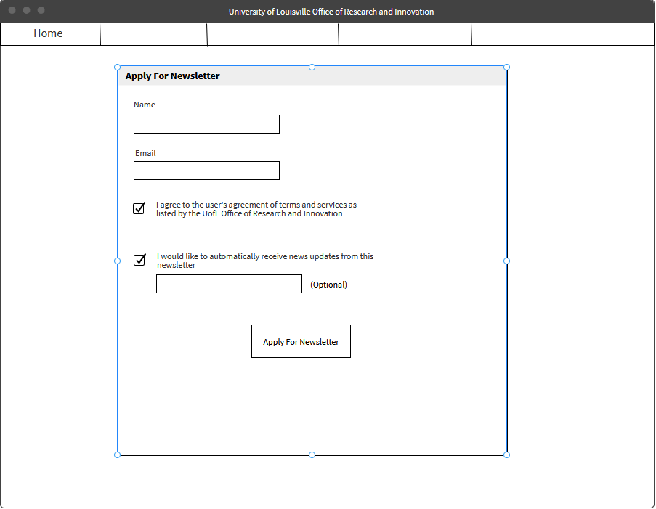

Layout 16

Apply for grant

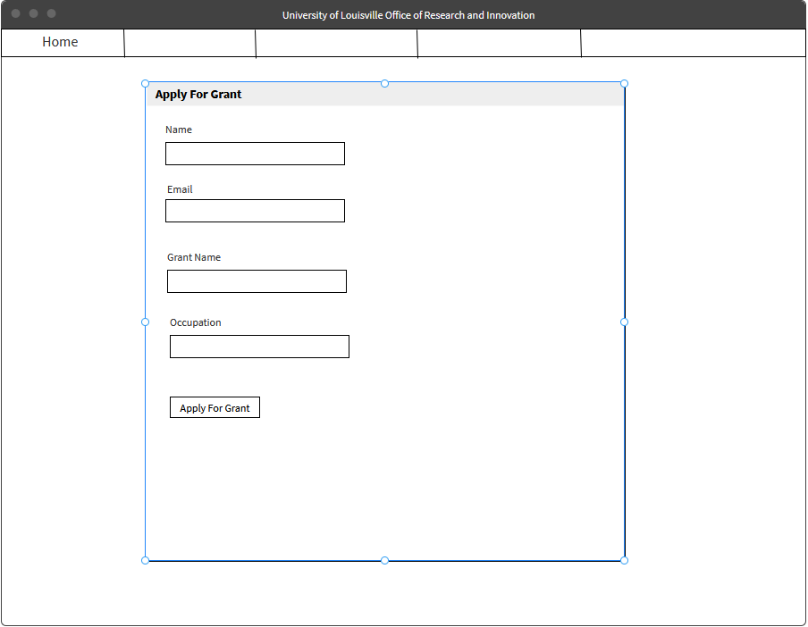

Layout 17

View proposals

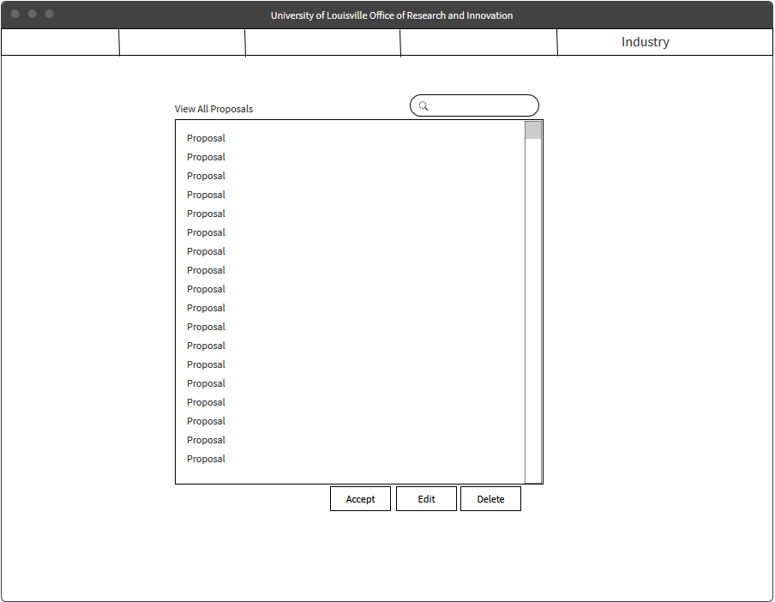

Layout 18

Physical Architecture Design

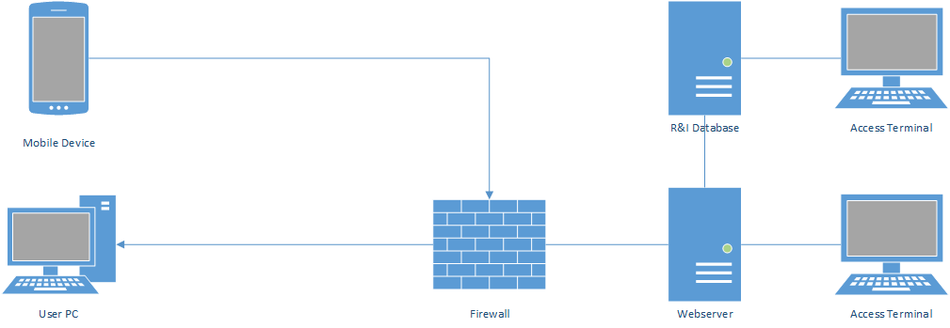

Mobile and desktop users will be able to access the website protected by the university firewall. The web server hosting the site will be connected to the Research and Innovation database which contains user profiles and data to be displayed on the site. Access terminals for both the webserver and the database will allow for administrative access whenever changes to the site or database are required.

Access Terminals and Web Server will run Windows Server 2019 while the database runs either Oracle or Windows Azure depending on if a cloud solution is needed

Design Procedures for Security Concerns and Non-functional Requirements

**Efficiency**

Scale up or down correctly, depending on what the needed capacity is for users, terminals, transactions etc.

Consider what to do when the system is overloaded. Decide whether to let the system run at a decreased rate of performance or allow the system to crash.

**Usability**

Find problems in the UI design, make recommendations to fix them and implement the fixes.

Improving UI design throughout the usage of the system.

* Create criteria to evaluate the UI design against

**Safety**

Make sure the safety of classes is of the utmost importance.

Implement methods to decrease the chances of safety failures

* Hazard avoidance
* Hazard detection
* Hazard removal
* Damage control

Run analysis on possible hazards and risks

* Identify risks
* Risk analysis
* Risk reduction/removal

**Security**

Make sure the security is up to date and properly working.

Deny service to interior and exterior threats.

Monitor corruption of programs, data or the system as a whole.

Implement detection and neutralization systems.

Limit damage if the system becomes compromised.

Gantt Chart

This Gantt Chart lists the tasks of a project and the duration of how long tasks will

take, as well as their dependencies.

Iteration 3

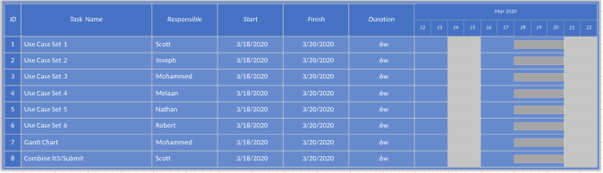

Iteration 5

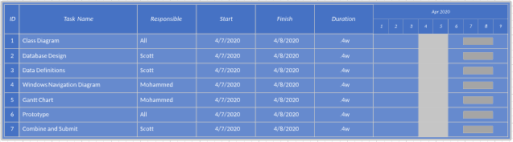

Elaboration Specification

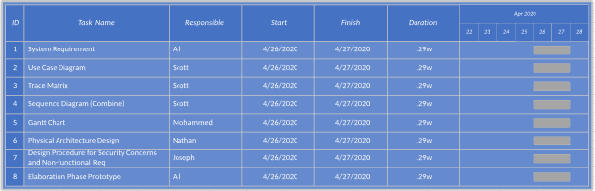

Elaboration Phase Prototypes

Figure 1 below is what we imagine the new and improved landing page would look like. It has a new infographic that can be used to show off any interesting statistics. It also has a new widget used to search for connections. The events widget is an upgrade over the current one. This landing page also prominently features the R&I social media.



Figure 1

Figure 2 below shows what the community landing page might look like. Considering there was not an existing one on the current R&I website, we took a few liberties in putting what we thought should exist on the page.



Figure 2

Figure 3 below shows what a new industry landing page might look like. Since there is not an existing page dedicated to industries on the site currently, we added what we thought would be beneficial for those stakeholders to see.



Figure 3

Figure 4 below shows what a new researcher landing page might look like. It includes a direct login to iRIS as well as a drop down for forms and a section for funding. It also includes infographics for each of the main facility types. At the base, there is a section for any relevant links



Figure 4

Figure 5 below shows what a new student landing page might look like. It features two sections for undergrad and graduate students that will contain any relevant information. It also has an events section and placeholders for videos. We saw that the current version included a few videos, so we wanted to ensure those were accounted for.



Figure 5

Figure 6 below shows what users might see when they look up the core research facilities that R&I offer. The current version is almost too minimal. This lets users scroll through existing facilities then click and expand the options to get more information. A link is provided that will take users to a separate page where all relevant information on each facility is located.



Figure 6